Norwegian National Seismic Network

Technical Report No. 31

Processing data for the ScanARRAY for events in Finnmark

Prepared by

NIL ERYILMAZ

Dept. of Earth Science, University of Bergen
Allégt.41, N-5007 Bergen, Norway
Tel: +47-55-583600 E-mail: seismo@geo.uib.no

May 2019
1. Introduction

In the Finnmark area of Northern Norway, there are postglacial faults (Figure 1). These faults are seen in the seismicity recorded in the NNSN data base. The NNSN database contains 597 events from the area (Figure 2). However, there are few seismic stations nearby limiting the accuracy of the epicenters.
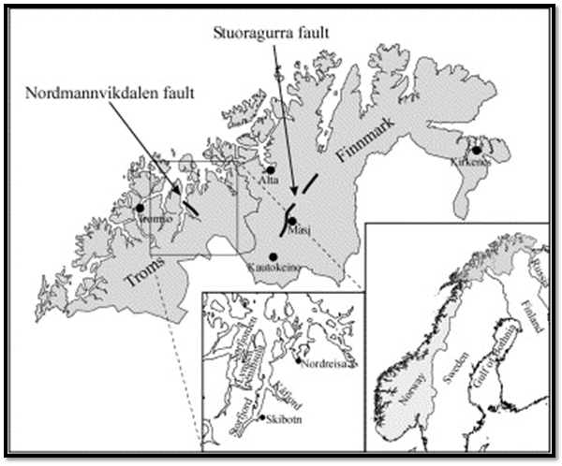Figure 1: Location of the Nordmannvikdalen and Stuoragurra postglacial faults in northern Norway. (Dehls et al., 2000).

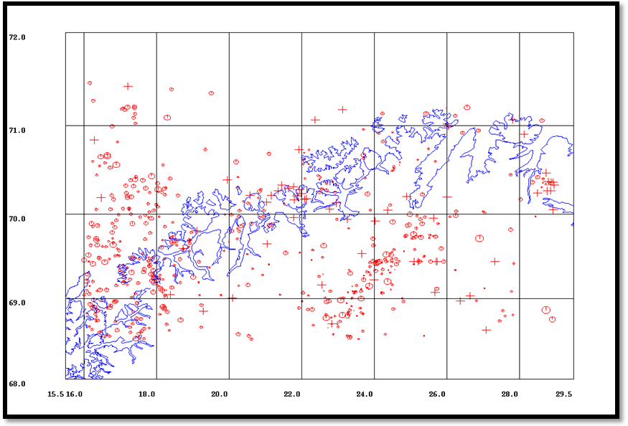
Figure 2: 597 NNSN events in Northern Norway area from 1980 to 2019. Explosions and probable explosions are excluded.

From June, 2013 to end of 2016, the ScanARRAY (Thybo et al., 2012) temporary stations operated in Northern Norway (Figure 3). The purpose of this study is to complement the NNSN data base with readings from the ScanARRAY to better define the seismicity in the area.
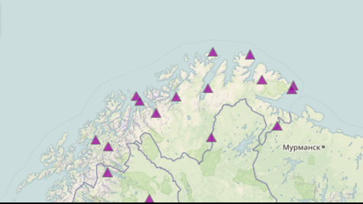
Figure 3: ScanArray seismic stations in Finnmark (Thybo et al., 2012)

The ScanARRAY operated between the dates June, 2013 and the end of 2016. The area was selected to be studied was 68.5-71.5° N and 16-32° E (Figure 4).
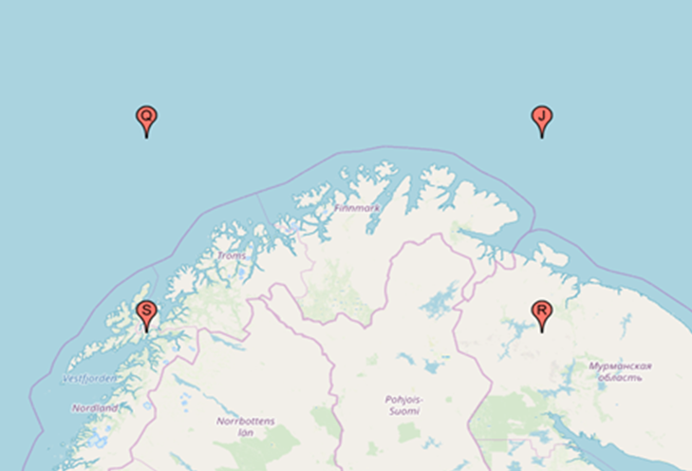

N : 71° 30` 0.0”
E : 32° 0` 0.0”

N : 71° 30` 0.0”
E : 16° 0` 0.0”

N : 68° 30` 0.0”
E : 32° 0` 0.0”

N : 68° 30` 0.0”
E : 16° 0` 0.0”

Figure 4: The coordinates of study area.

In the NNSN data base, there were 148 earthquakes in the study period and area. Notice the alienation of the fault (Figure 5,6 and 7).
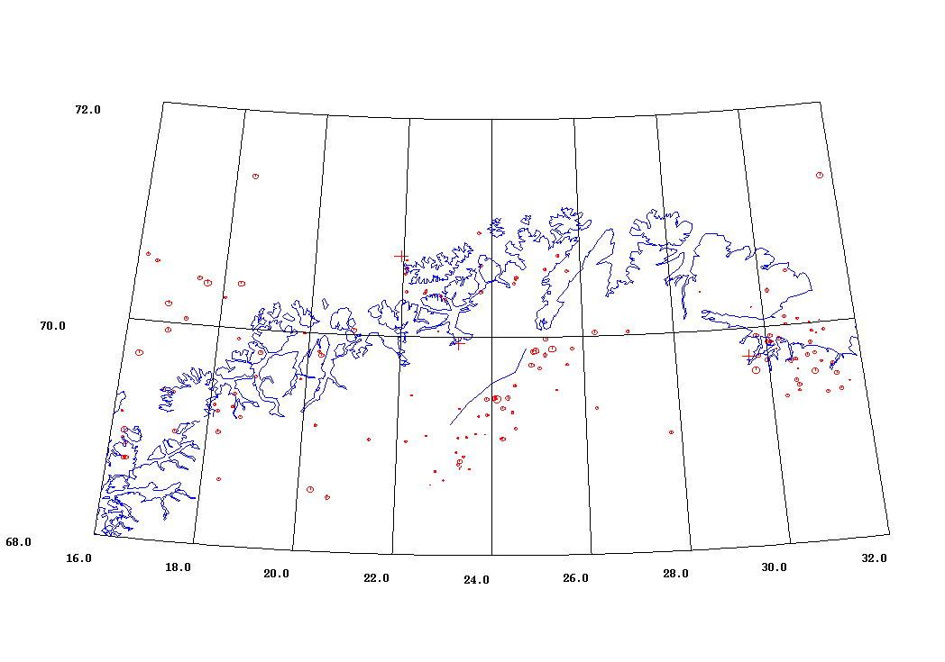
Figure 5: Earthquake locations for the study area and time period. Explosions and probable explosions are not included. Alienation of Stuoragurra fault (blue line).

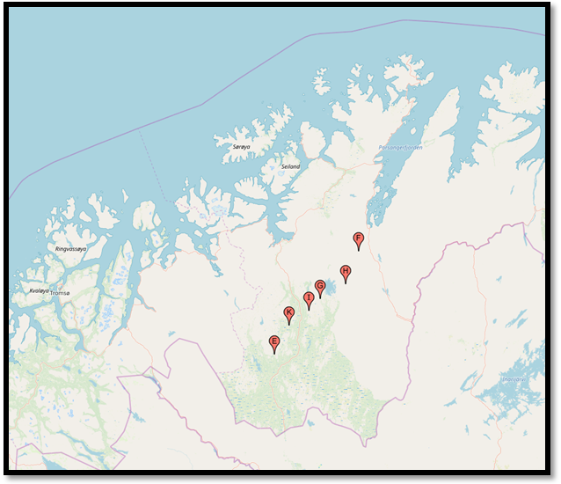
Figure 6: The digitized points on Stuoragurra fault line. (E: 69.20° N-32.12° E, K:69.40° N-23.50° E, I: 69.50° N-23.78° E, G: 69.58° N-24° E, H: 69.68° N-24.50° E, F: 69.90° N-24.75° E)

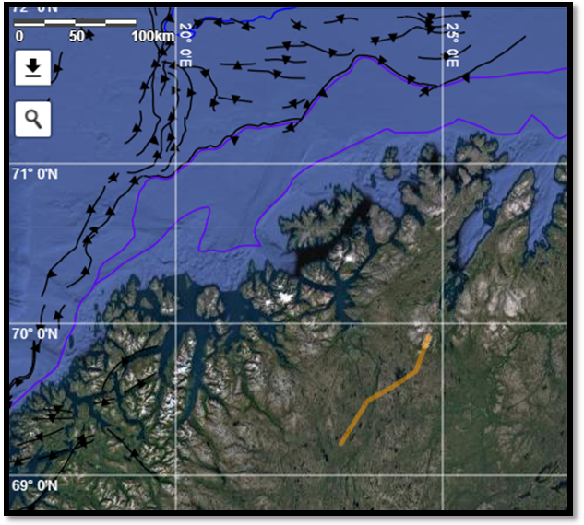
Figure 7: Stuoragurra fault (yellow line).

Since many of the earthquakes were very small and unlikely to be recorded on the noisy field stations, we started to check only the events with magnitude larger than or equal to 1.5, see Figure 8.

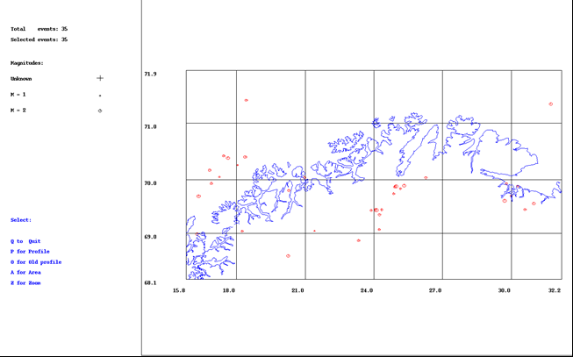

Figure 8: Earthquake locations for the study area from June 2013 to end of 2016 with magnitude ≥1.5.
Waveforms for the 35 events were extracted from the ScanARRAY archive at the GFZ. The events were picked with P and S waves and amplitudes were read. Magnitudes (ML) were calculated and the events were located together with the NNSN readings. The table below illustrates the old data which was already registered in NNSN and the combined version of the old data with ScanARRAY data.

Table 1: Combination of NNSN and ScanARRAY data (1st line of each hypocenter pair) and old NNSN (2nd line) location. Abbreviations are: lat: latitude, lon: longitude,agen: agency, SN: number of stations, mag1,23,: Magnitudes.

1
2013 8 1 0313 16.3 L 68.510 20.202 18.0 BER 30 1.2 2.1LBER 2.8WBER 2.8LNAO
OLD: 8 1 313 17.0 L 68.563 20.261 22.5 BER 18 .90 2.0LBER 2.8LNAO
2
2013 816 1601 36.2 LQ 70.293 17.943 12.2 BER 12 0.6 1.1LBER 2.0LNAO
OLD: 816 1601 37.2 LQ 70.262 18.043 15.0 BER 10 0.6 0.9LBER 2.0LNAO
3
2013 1013 1852 17.1 LQ 69.864 24.917 13.0F BER 30 0.9 2.4LBER 2.7LNAO
OLD: 1013 1852 16.7 LQ 69.878 24.966 13.0F BER 22 0.8 2.2LBER 2.7LNAO
4
2013 12 6 1927 59.6 LQ 70.145 16.717 2.6 BER 34 0.9 1.9LBER 2.8WBER 2.5LNAO
OLD: 12 6 1927 59.6 LQ 70.172 16.820 1.90 BER 20 .50 1.9LBER 2.5LNAO
5
2014 118 1859 29.9 LQ 69.867 25.261 0.5 BER 35 0.6 2.4LBER 3.1WBER 2.8LNAO
OLD: 118 1859 29.9 LQ 69.889 25.319 4.50 BER 24 .60 2.3LBER 2.8LNAO
6
2014 325 0412 46.8 LQ 69.456 24.298 11.0F BER 18 1.2 1.5LBER 1.6LHEL
OLD: 325 412 46.9 LQ 69.444 24.341 11.0F BER 11 .90 1.5LBER 1.6LHEL
7
2014 514 2204 36.5 LQ 70.379 17.674 12.1 BER 12 0.4 1.4LBER
OLD: 514 22 4 37.1 LQ 70.428 17.441 31.0 BER 5 .20 1.6LBER
8
2014 819 1500 20.4 L 69.647 29.909 0.0 BER 11 0.8 1.6LBER 2.5LNAO
OLD: 819 1500 22.1 L 69.609 29.706 0.0 BER 5 0.5 2.5LNAO
9
2014 829 0255 50.4 L 69.068 21.557 0.0 BER 17 1.2 1.8LBER 1.5LHEL
OLD: 829 0255 50.2 L 69.045 21.406 12.1 BER 10 0.7 0.9LBER 1.5LHEL
10
2014 9 3 2258 47.9 L 69.036 18.251 15.0 BER 23 1.6 1.5LBER 1.5LHEL
OLD: 9 3 2258 47.8 L 69.040 18.238 15.0 BER 16 1.8 1.5LBER 1.5LHEL
11
2014 1121 1208 46.3 L 69.679 30.093 0.0 BER 8 1.1 1.4LBER 1.7WBER
OLD: 1121 12 8 47.4 L 69.882 30.283 15.0 BER 4 .80 1.5LBER
12
2014 1223 1925 52.7 LQ 69.743 24.883 12.7 BER 23 0.3 1.6LBER 2.0WBER 1.7LHEL
OLD: 1223 1925 52.7 LQ 69.742 24.863 13.1 BER 18 .30 1.5LBER 1.7LHEL
13
2015 4 3 1850 15.7 L 69.415 30.650 15.0 BER 19 1.6 1.6LBER 1.9LHEL
OLD: 4 3 1850 15.5 L 69.449 30.602 15.0 BER 13 1.0 1.5LBER 1.9LHEL
14
2015 6 1 0842 21.0 LQ 70.396 18.373 15.0 BER 22 0.7 2.1LBER 2.5LNAO
OLD: 6 1 0842 20.7 LQ 70.408 18.379 15.0 BER 12 0.5 1.9LBER 2.5LNAO
15
2015 625 2315 57.6 L 69.446 31.007 0.0 BER 23 1.0 2.1LBER
OLD: 625 2315 57.1 L 69.559 30.977 0.00 BER 13 .60 2.1LBER
16
2015 720 0236 54.8 LQ 68.853 23.335 8.8 BER 22 0.3 1.7LBER 2.0LNAO
OLD: 720 0236 54.7 LQ 68.860 23.330 11.1 BER 16 0.2 1.6LBER 2.0LNAO
17
2015 721 0656 49.7 L 69.649 29.994 0.0 BER 18 0.9 1.8LBER 2.4LNAO
OLD: 721 0656 50.9 L 69.699 29.998 15.0 BER 9 0.6 1.5LBER 2.4LNAO
18
2015 731 1727 58.8 LQ 69.348 24.238 6.0 BER 17 0.6 1.7LBER 1.5LHEL
OLD: 731 1727 58.7 LQ 69.349 24.237 6.1 BER 14 0.6 1.6LBER 1.5LHEL
19
2015 8 1 1142 43.1 LQ 69.439 24.112 15.0 BER 71 1.4 2.7LBER 2.8LHEL
OLD: 8 1 1142 42.7 LQ 69.435 24.106 15.0 BER 37 .80 2.7LBER 2.8WBER 2.8LHEL
20
2015 814 1128 56.2 L 69.669 29.872 0.0 BER 9 1.2 1.7LBER
OLD: 814 1128 55.4 L 69.925 29.792 0.0 BER 5 0.7 1.6LBER
21
2015 922 1101 8.9 LQ 69.954 21.071 0.0 BER 26 0.9 1.8LBER 2.0WBER 1.8LHEL
OLD: 922 1101 8.3 LQ 70.040 20.965 7.2 BER 17 0.6 1.7LBER 2.0WBER 1.8LHEL
22
2015 930 2331 12.6 LQ 69.432 23.879 0.0 BER 24 0.5 1.6LBER 1.9WBER 1.7LHEL
OLD: 930 2331 12.5 LQ 69.431 23.887 2.0 BER 18 0.5 1.4LBER 1.9WBER 1.7LHEL
23
2015 1024 1312 16.0 L 69.829 20.492 0.0 BER 23 0.9 1.7LBER 2.4LNAO
OLD: 1024 1312 16.9 L 69.801 20.286 15.0 BER 18 0.5 1.6LBER 2.4LNAO
24
2015 1026 0449 14.7 LQ 69.453 24.061 15.0 BER 16 0.5 1.5LBER 1.8LNAO
OLD: 1026 0449 14.8 LQ 69.444 24.055 15.0 BER 12 0.5 1.5LBER 1.8LNAO
25
2015 1027 2034 52.8 LQ 69.839 25.122 0.0 BER 16 0.4 1.5LBER 1.6LHEL
OLD: 1027 2034 52.9 LQ 69.837 25.162 8.2 BER 12 0.5 1.4LBER 1.6LHEL
26
2015 1117 1614 6.7 LQ 68.980 16.280 16.2 BER 49 0.7 2.6LBER 2.3WBER 2.1LHEL
OLD: 1117 1614 6.7 LQ 68.983 16.275 16.6 BER 46 .70 2.2LBER 2.3WBER 2.1LHEL
27
2015 1120 1543 19.6 LQ 71.306 31.779 15.0 BER 14 0.9 2.3LBER 2.4LNAO
OLD: 1120 1543 18.8 LQ 71.333 31.724 12.1 BER 10 .60 2.1LBER 2.4LNAO
28
2015 1126 2359 1.8 LQ 69.924 16.913 15.0 BER 13 0.4 1.6LBER 1.6LHEL
OLD: 1126 2359 1.5 LQ 69.930 16.893 12.1 BER 11 0.3 1.6LBER 1.6LHEL
29
2015 12 4 0425 57.4 LQ 69.070 24.219 4.8 BER 32 0.7 1.7LBER 1.9WBER 1.6LHEL
OLD: 12 4 0425 57.3 LQ 69.068 24.230 4.4 BER 28 0.7 1.5LBER 1.9WBER 1.6LHEL
30
2016 316 0436 5.8 LQ 69.869 24.907 0.1 BER 20 0.7 1.8LBER 1.8LHEL
OLD: 316 0436 5.8 LQ 69.868 24.908 0.1 BER 14 0.7 1.8LBER 1.8LHEL
31
2016 421 0054 27.5 LQ 69.714 16.279 15.0 BER 31 0.9 2.3LBER 2.6LHEL
OLD: 421 0054 28.1 LQ 69.697 16.341 18.1 BER 19 0.5 2.1LBER 2.6LHEL
32
2016 625 0123 39.0 LQ 70.007 17.290 0.0 BER 17 0.7 1.2LBER 1.5LHEL
OLD: 625 0123 38.7 LQ 70.049 17.253 0.4 BER 15 0.4 1.1LBER 1.5LHEL
33
2016 715 0406 48.7 LQ 70.055 26.205 15.3 BER 15 0.7 1.5LBER 1.8LHEL
OLD: 715 0406 48.7 LQ 70.034 26.264 21.1 BER 13 0.7 1.6LBER 1.8LHEL
34
2016 722 0502 43.6 LQ 71.398 18.408 15.0F BER 21 0.5 1.6LBER 2.6LNAO
OLD: 722 0502 43.5 LQ 71.398 18.421 15.0F BER 20 0.5 1.6LBER 2.6LNAO
35
2016 1218 1242 14.0 LQ 70.388 17.624 15.0 BER 17 0.8 2.1LBER 2.1LHEL
OLD: 1218 1242 14.0 LQ 70.389 17.624 15.0 BER 16 0.8 2.2LBER 2.1LHEL

35 events which are combination of both data sources were located (Figure 9). Notice that all events were recorded on the ScanARRAY, but some with only a few stations.
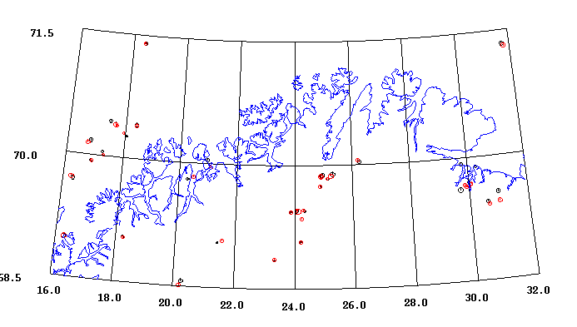

Figure 9: New and old locations of the events with M_{L} ≥1.5. The old locations are black and new red. Notice the alienation in central Finnmark.

The mapped fault does not correspond to the epicenters. This was also observed in earlier studies, see Figure 10.
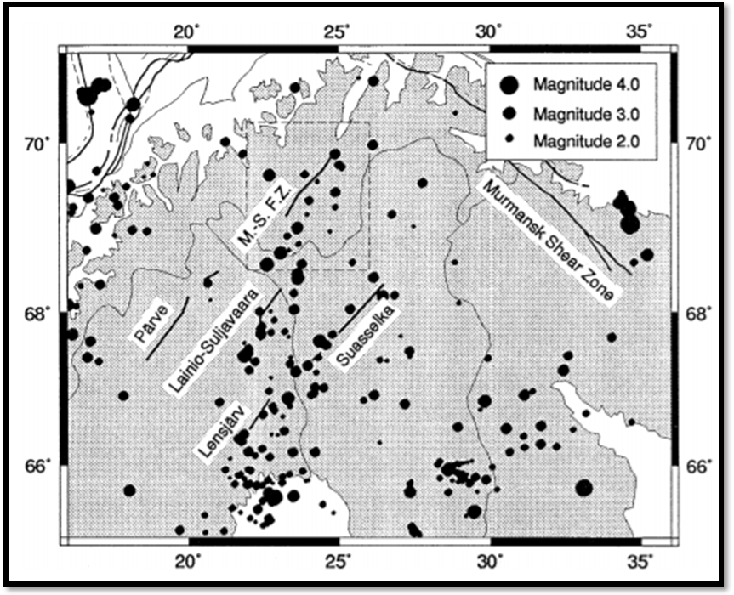
Figure 10: Distribution of the earthquakes along the fault line. (Bungum and Lindholm, 1996)

The average difference between old and new locations was calculated, see Table 2.

Table 2: Differences between new and old locations. The compared content is origin time, RMS, hypocenter and magnitudes. For each parameter, the average difference with standard deviations is calculated.
Origin time RMS Lat Lon Depth Ml
Average diff 0.1 -0.2 0.025 -0.012 3.6 0.0
Standard dev 0.6 0.2 0.060 0.086 5.7 0.0
Number of values 35 31 35

Fault Plane Solution

The event with largest number of readings in the area is the event with magnitude M_{L}= 2.7, August 1, 2015. This was also the largest event in this data set. The event was relocated with stations less than 150 km distance (xnear=50, xfar=150). A new depth of 9 km was obtained. Depth was then fixed to 9 km. The fault plane solution was made with polarity. The solutions with FOCMEC (blue), PINV (green) and FPFIT (red) are shown in Figure 11. All had one polarity error and degree increment (spacing in the grid search) is 2 degrees.
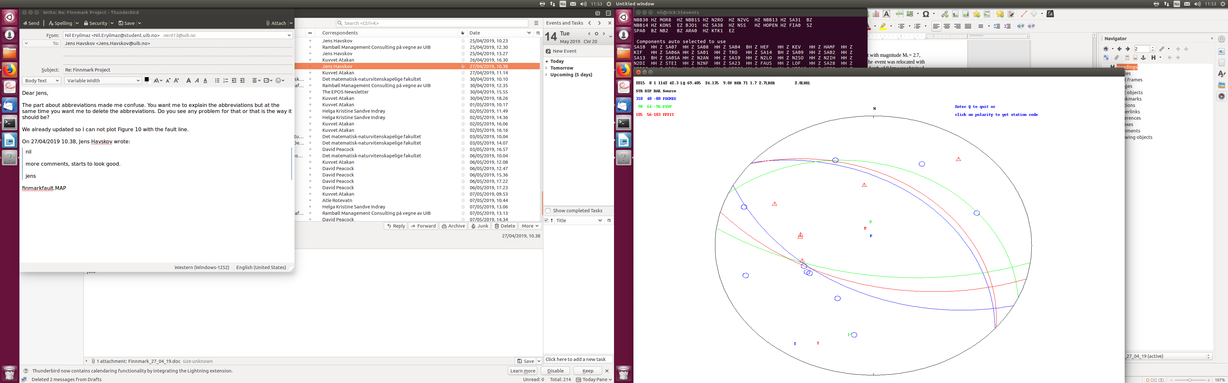
Figure 11: Fault plane solution with 16 polarities and one error. All 3 solutions are similar.

The error was on KTK1 but it is a very clear dilatational signal, see Figure 12.
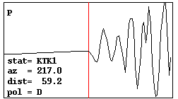
Figure 12: First motion on station KTK1.
The fault plane solution was also made with depths 5 and 15km (Figure 13, 14) and the solutions were very similar to the solution at 9 km. The solutions at 9 km were kept as the final solution.

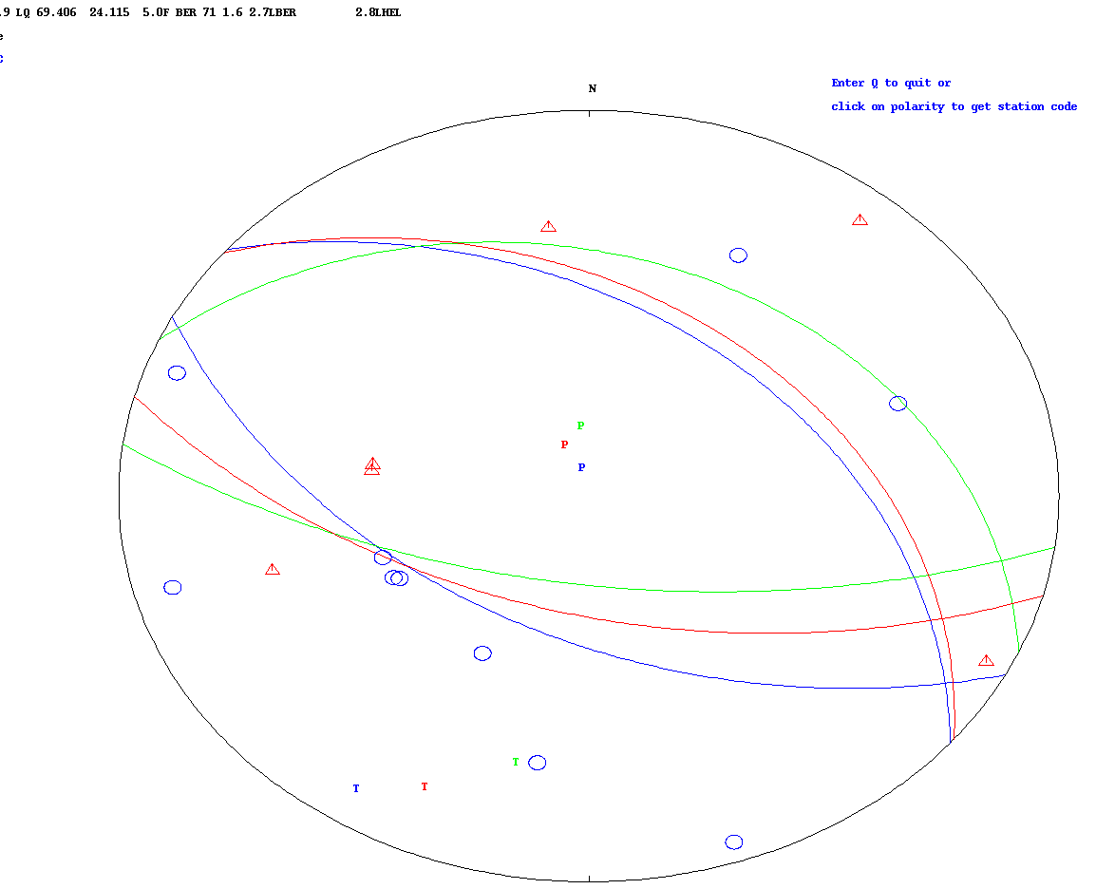

Figure 13: Fault plane solutions for depth fixed to 5 km.
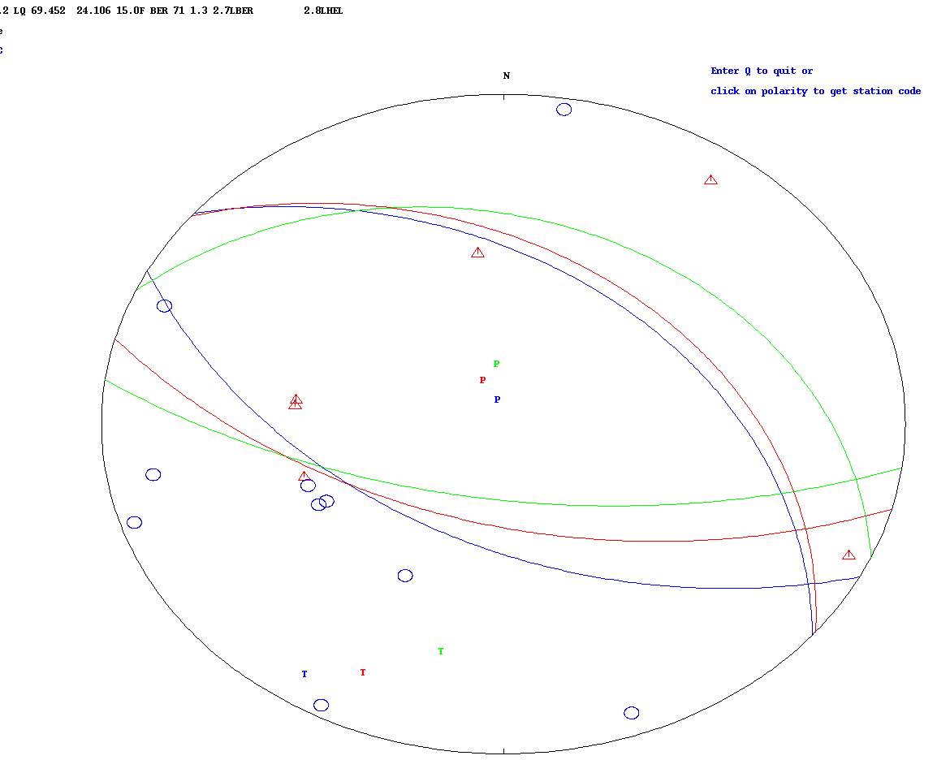

Figure 14: Fault plane solutions for depth fixed to 15km.
Events near the fault were selected with magnitude smaller than 1.5 in central Finnmark area in order to check if reading were possible for those smaller events (Figure 15). Consequently, 33 events were found (Table 2).
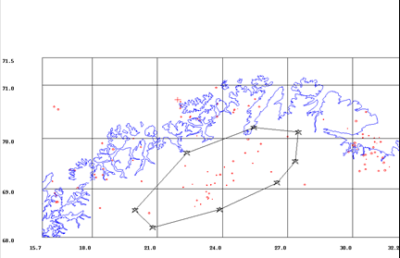
Figure 15: Location of the data with magnitude smaller than 1.5 in central Finnmark. The 33 events selected are inside the polygon.

Table 3: 33 events magnitude smaller than 1.5 in central Finnmark. Combination of NNSN and ScanARRAY data (1st line of each hypocenter pair) and old NNSN (2nd line) location. New means a new event was found. There are 14 events which does not have a new phases. Abbreviations are: lat: latitude, lon: longitude,agen: agency, SN: number of stations, mag1,23,: Magnitudes.

1
2013 919 1824 25.3 LQ 69.891 25.786 2.3 BER 10 0.7 1.0LBER 2.0WBER 1.3LHEL
OLD: 919 1824 25.3 LQ 69.891 25.763 1.0 BER 8 0.6 1.2LBER 1.3LHEL
2
2013 1026 1722 51.6 LQ 68.894 23.385 9.7 BER 15 0.8 0.9LBER
OLD: 1026 1722 51.7 LQ 68.907 23.380 11.9 BER 13 0.9 0.9LBER
3
2013 1030 1229 4.5 LQ 68.498 20.573 0.0 BER 18 0.9 1.4LBER
OLD: 1030 1229 6.0 LQ 68.502 20.620 13.6 BER 13 0.9 1.4LBER
4
2013 11 5 2140 57.5 LQ 68.785 23.542 15.0 BER 6 0.4 0.5LBER 0.3LHEL
OLD: 11 5 2140 57.6 LQ 68.790 23.527 12.7 BER 6 0.3 0.5LBER 0.3LHEL
5
2014 2 5 1431 53.1 LQ 69.331 26.258 0.0 BER 8 0.5 1.0LBER 1.0LHEL
OLD: 2 5 1431 53.2 LQ 69.342 26.244 3.4 BER 7 0.5 0.9LBER 1.0LHEL
6
2014 223 2335 4.6 LQ 69.039 22.201 14.8 BER 8 0.7 0.6LBER 0.7LHEL
OLD: 223 2335 4.5 LQ 69.037 22.190 16.1 BER 7 0.7 0.7LBER 0.7LHEL
7
2014 623 1456 42.2 L 68.768 22.825 0.0 BER 9 0.6 0.7LBER 1.0LHEL
OLD: 623 1456 42.2 L 68.767 22.821 0.0 BER 7 0.6 0.8LBER 1.0LHEL
8
2015 214 0145 22.6 LQ 69.076 23.279 3.0 BER 10 0.5 0.7LBER 0.8LHEL
OLD: 214 0145 22.6 LQ 69.076 23.279 3.0 BER 10 0.5 0.7LBER 0.8LHEL
9
2015 4 5 1120 55.9 LQ 69.084 23.467 7.5 BER 10 0.6 0.8LBER 1.0LHEL
OLD: 4 5 1120 55.9 LQ 69.084 23.463 7.4 BER 9 0.6 0.7LBER 1.0LHEL
10
2015 415 2236 28.3 LQ 70.046 27.211 3.2 BER 14 0.6 0.9LBER 1.0LHEL
OLD: 415 2236 29.4 LQ 70.033 26.997 1.3 BER 10 0.5 0.9LBER 1.0LHEL
11
2015 5 1 1207 16.4 LQ 68.833 23.307 6.1 BER 16 0.6 1.1LBER 1.2LHEL
OLD: 5 1 1207 16.3 LQ 68.834 23.295 3.8 BER 14 0.5 1.0LBER 1.2LHEL
12
2015 610 1344 16.4 L 68.687 22.992 0.0 BER 3 0.6 0.5LBER
OLD: 610 1344 16.4 L 68.687 22.992 0.0 BER 3 0.6 0.5LBER
13
2015 715 1720 25.9 LQ 69.957 25.147 13.3 BER 13 0.6 1.4LBER 1.2LHEL
OLD: 715 1720 25.7 LQ 69.981 25.182 15.9 BER 9 0.6 1.4LBER 1.2LHEL
14
2015 715 2307 12.8 LQ 68.944 23.250 4.0 BER 10 0.4 0.7LBER 0.8LHEL
OLD: 715 2307 12.8 LQ 68.944 23.250 4.0 BER 10 0.4 0.7LBER 0.8LHEL
15
2015 719 2250 54.5 LQ 69.310 23.847 0.0 BER 21 0.7 1.2LBER 1.0LHEL
OLD: 719 2250 55.4 LQ 69.286 23.898 15.0 BER 15 0.6 1.1LBER 1.0LHEL
16
2015 729 2321 21.4 LQ 69.567 24.471 15.0 BER 13 0.6 0.9LBER 0.9LHEL
OLD: 729 2321 21.5 LQ 69.556 24.495 15.0 BER 11 0.6 1.0LBER 0.9LHEL
17
2015 812 1240 23.8 LQ 69.722 25.010 2.6 BER 12 0.7 1.1LBER 1.1LHEL
OLD: 812 1240 23.8 LQ 69.716 25.037 3.0 BER 9 0.7 0.9LBER 1.1LHEL
18
2015 921 2127 13.2 LQ 69.074 24.190 12.9 BER 10 0.7 0.5LBER 0.7LHEL
OLD: 921 2127 13.2 LQ 69.074 24.190 12.9 BER 10 0.7 0.5LBER 0.7LHEL
19
2015 923 1251 29.5 LQ 69.514 25.393 8.7 BER 8 0.9 0.6LBER 0.9LHEL
OLD: 923 1251 29.5 LQ 69.514 25.393 8.7 BER 8 0.9 0.6LBER 0.9LHEL
20
2015 1012 1732 16.6 LQ 69.745 25.635 14.9 BER 5 0.7 0.6LBER 0.5LHEL
OLD: 1012 1732 16.6 LQ 69.745 25.635 14.9 BER 5 0.7 0.6LBER 0.5LHEL
21- New, probably an explosion
2015 1013 2324 50.6 LP 67.702 20.745 0.0 BER 11 0.9 1.5LBER 2.1WBER
OLD: 1013 2322 44.0 LP BER 2
22- New, probably an explosion
2015 1013 2328 53.4 LP 67.832 20.373 0.0 BER 21 1.5 2.2LBER 2.4WBER
OLD: 1013 2328 21.0 LP BER 2
23
2016 115 0416 14.9 LQ 69.191 24.431 10.0 BER 10 0.5 1.0LBER
OLD: 115 0416 14.7 LQ 69.167 24.503 10.2 BER 8 0.4 1.0LBER
24- New, probably an explosion
2016 115 0422 19.2 LP 66.447 14.494 0.0 BER 17 1.8 1.0LBER 1.7WBER
OLD: 115 0422 16.7 LE 66.410 14.745 0.0F BER 6 0.4 1.0LBER
25
2016 726 1314 7.6 LQ 69.112 23.662 1.7 BER 11 0.7 0.6LBER 0.6LHEL
OLD: 726 1314 7.6 LQ 69.114 23.649 3.1 BER 9 0.7 0.6LBER 0.6LHEL
26
2016 821 1818 21.4 L 68.815 23.373 0.0 BER 9 0.6 0.2LBER 0.4LHEL
OLD: 821 1818 21.4 L 68.816 23.364 0.0 BER 8 0.6 0.2LBER 0.4LHEL
27
2016 822 0810 3.1 L 68.642 22.729 0.0 BER 9 0.8 0.2LBER 0.7LHEL
OLD: 822 0810 3.1 L 68.642 22.729 0.0 BER 9 0.8 0.2LBER 0.7LHEL
28
2016 9 2 1250 10.6 LQ 69.093 22.615 12.2 BER 5 0.3 0.4LBER
OLD: 9 2 1250 10.6 LQ 69.093 22.615 12.2 BER 5 0.3 0.4LBER
29
2016 919 1131 16.1 LQ 68.803 23.336 8.3 BER 9 0.5 0.2LBER 0.3LHEL
OLD: 919 1131 16.1 LQ 68.803 23.336 8.3 BER 9 0.5 0.2LBER 0.3LHEL
30
2016 10 5 2109 0.9 LQ 69.345 23.311 6.1 BER 7 0.8 0.6LBER
OLD: 10 5 2109 0.9 LQ 69.345 23.311 6.1 BER 7 0.8 0.6LBER
31
2016 10 8 0517 9.4 LQ 69.315 24.444 10.5 BER 12 0.6 0.8LBER 1.1LHEL
OLD: 10 8 0517 9.4 LQ 69.313 24.442 10.4 BER 11 0.6 0.8LBER 1.1LHEL
32
2016 1031 1032 6.2 LQ 69.459 22.283 2.4 BER 8 0.5 0.7LBER 0.7LHEL
OLD: 1031 1032 6.2 LQ 69.462 22.281 3.1 BER 7 0.5 0.6LBER 0.7LHEL
33
2016 11 2 0708 21.0 LQ 68.790 23.325 15.0 BER 6 0.4 0.2LBER 0.5LHEL
OLD: 11 2 0708 21.0 LQ 68.790 23.325 15.0 BER 6 0.4 0.2LBER 0.5LHEL
34
2016 1114 0601 47.2 LQ 69.276 23.719 3.4 BER 7 0.6 0.6LBER 0.6LHEL
OLD: 1114 0601 47.2 LQ 69.276 23.719 3.4 BER 7 0.6 0.6LBER 0.6LHEL
35
2016 1226 0715 44.2 LQ 69.109 23.856 19.1 BER 5 0.1 0.1LBER 0.6LHEL
OLD: 1226 0715 44.2 LQ 69.109 23.855 19.1 BER 5 0.1 0.1LBER 0.6LHEL

There are not many new readings from ScanARRAY. The 3 new events were not new but explosions in the NNSN data base (#21, #22 and #24) (Figure 16).
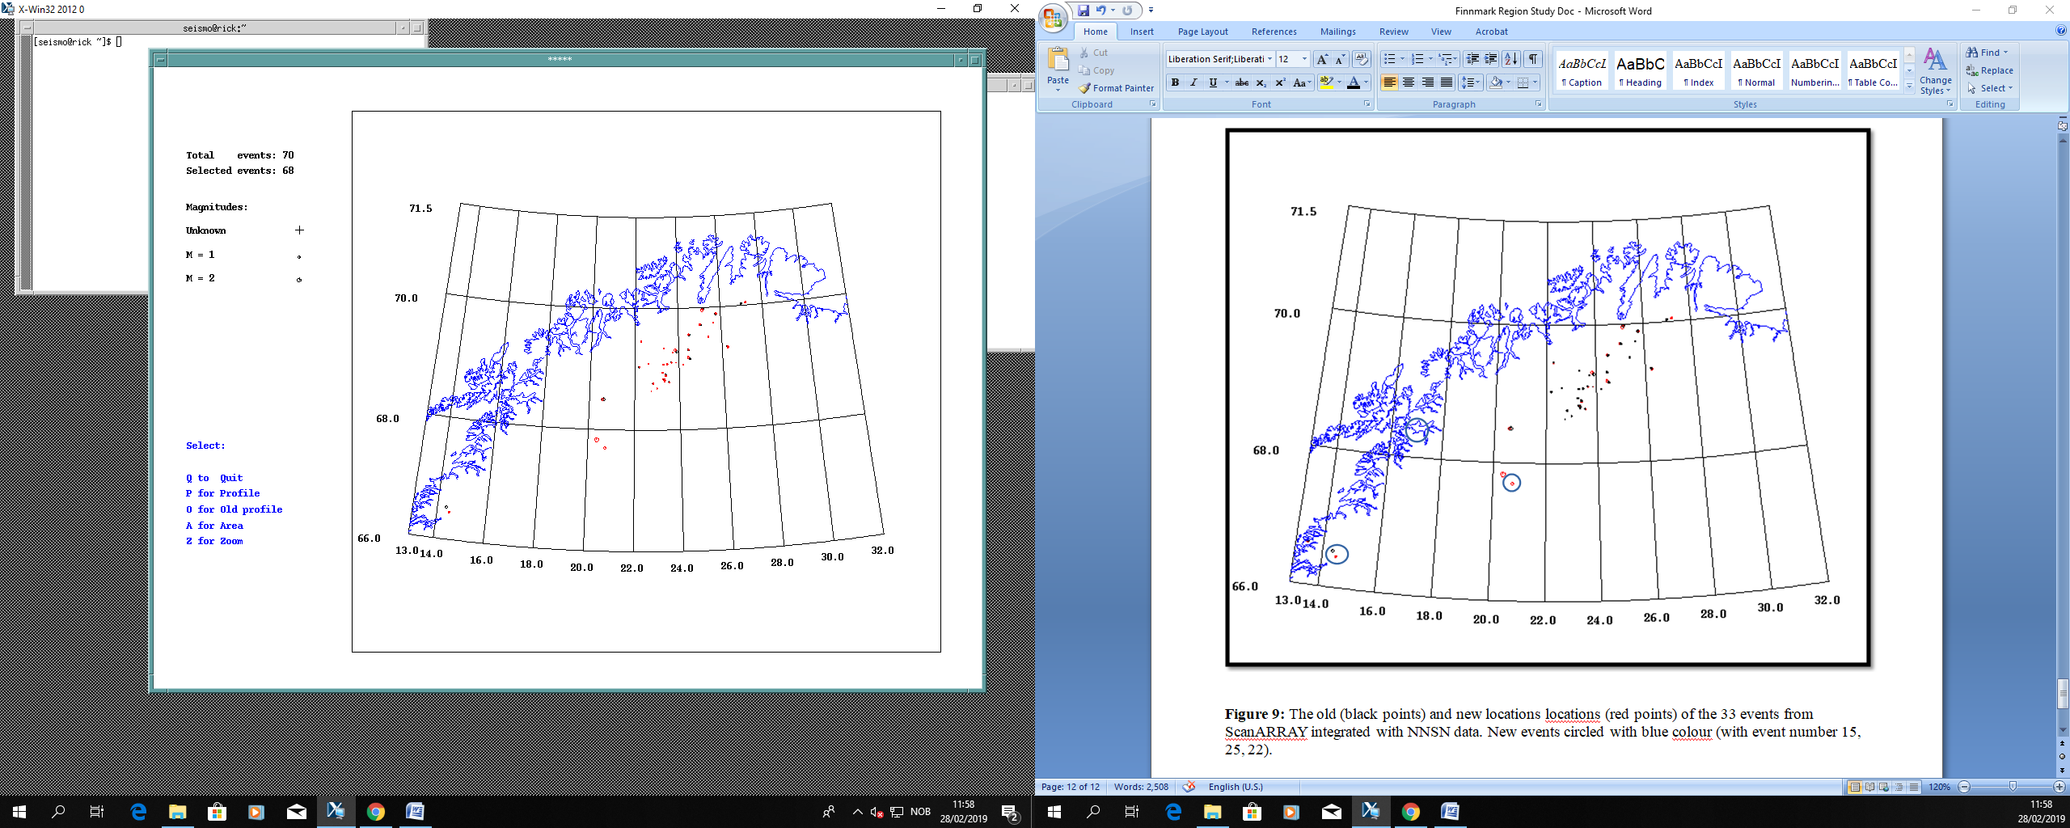

Figure 16: The old (black points) and new locations (red points) of the 33 events from ScanARRAY integrated with NNSN data. New events circled with blue colour (Circles with black, green, red refers to event number 22, 21 and 24 respectively).

Discussion and conclusion
Important contributors to the fault generating mechanisms are believed to be stress associated with spreading of the Mohns, Knipovich and Nansen Ridges and viscous drag underneath the lithosphere (Olesen, 1988). Reverse faulting in response to horizontal NW–SE compression often observed. The thrust faulting is also consistent with the tectonic regime indicated by the other neotectonic faults in Sweden and Finland. (Bungum and Lindholm, 1996).
In Nordland, inversion of focal mechanisms of earthquakes indicates a coast-perpendicular extensional stress regime with shallow earthquakes (Figure 17), which is directly opposite to what is found along the margin farther offshore (Hicks et al. 2000, Bungum et al. 2010). There are, however, also some strike-slip earthquakes here, with coastparallel compressions. This anomalous stress field (contrasting with the regional one) appears to be associated with a locally enhanced uplift pattern and a related flexuring mechanism. This may in turn be related to remaining glacioisostatic adjustments, but since very recent erosion has taken place in Nordland, the crust there may be strongly flexed, which also would result in coast-perpendicular extension. (Olesen et al., 2013)
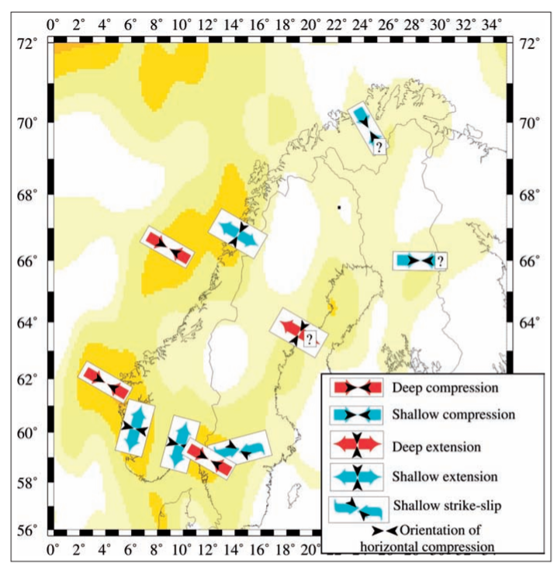
Figure 17: Stress orientations, type of faulting and focal depths synthesised from earthquake focal mechanisms and in situ stress measurements (from Fjeldskaar et al., 2000). Areas with sparse data are indicated with question marks. Intensity of yellow indicates intensity of seismicity. Note that offshore depocentres generally coincide with areas of dominating compressional events whereas the coastal areas have a predominantly extensional regime. (Olesen et al., 2013)

According to Olesen (1988) and Muir Wood (1989), “Stuoragurra fault occur along a physiographic border. The mountainous area to the northwest has an average higher elevation than the area to the southeast. The ice was consequently thickest in the southeastern area. This would have involved more depression during the period of maximum glaciation and consequently a greater contribution to the subsequent postglacial stress regime. The differential loading of ice across a prestressed zone of weakness might consequently be sufficient to have caused reactivation of the old zone, and so produce a fault scarp.”
The added readings for the 2 data sets did not seem to make a significant difference in the alignment of the epicenters in Finnmark. However, the new data provides one fault plane solution. The fault plane solution is not aligned with the fault which could indicate an uncertain solution. This situation is very common at the level of lower magnitudes (lower than 3).
New fault plane solution (see Figures 18,19) shows a normal fault pattern with the strike, dip and slip of 310 40 -79, respectively.

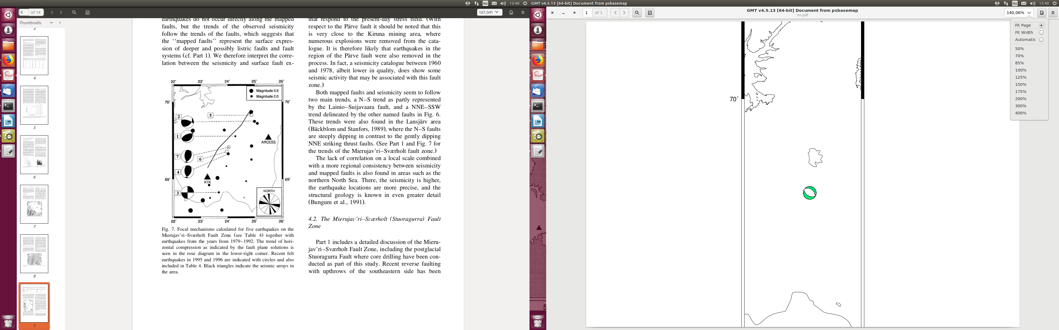
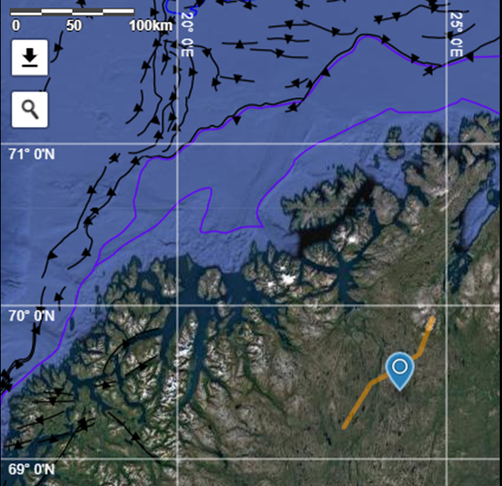
Figure 18: Location of the event with fault plane solution.

T
P

T

Figure 19: Forces that effect fault plane solution.

Acknowledgemets

Lars Ottemöller and Jens Havskov read this report and made valuable suggestions.

References

- National Norwegian Seismic Network (NNSN) database http://nnsn.geo.uib.no/nnsn/#/
- ScanARRAY temporary seismic stations database https://geofon.gfz-potsdam.de/waveform/archive/network.php?ncode=1G&year=2012
- Dehls, J.F., Olesen, O., Olsen, L., Blikra J.F. L.H., (2000). Quaternary Science Reviews 19 ,1447-1460.
- Thybo, H., Balling, N., Maupin, V., Ritter, J., and Tilmann, F., (2012), ScanArray Core (1G 2012–2017): The ScanArray consortium, Other/Seismic Network
- Olesen, O. (1988): The Stuoragurra Fault, evidence of neotectonics in the Precambrian of Finnmark, northem Norway. Norsk Geologisk Tidsskrift, 68,107-118.
- Bungum, H., Lindholm C., ( 1996 ) Tectonophysics 270, 15–28
- Olesen, O., Bungum, H., Dehls, J., Lindholm, C., Pascal, C. and Roberts, D. (2013). Neotectonics, seismicity and contemporary stress field in Norway – mechanisms and implications. In Olsen, L., Fredin, O. and Olesen, O. (eds.) Quaternary Geology of Norway, Geological Survey of Norway Special Publication, 13, 145–174.

