Norwegian National Seismic Network
Decade report 2001-2010

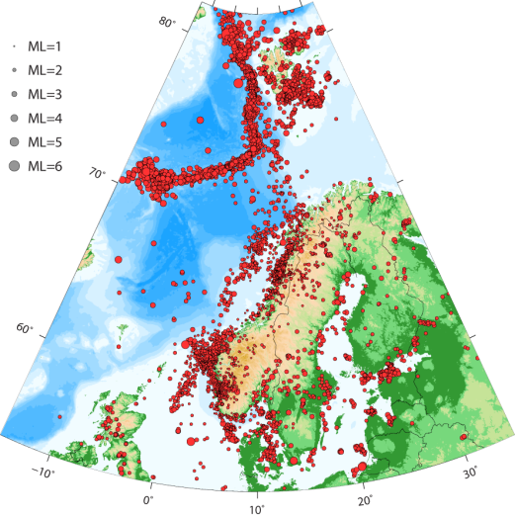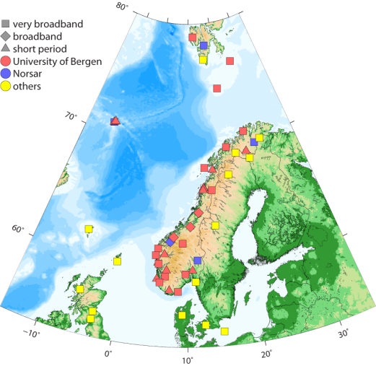

By

Lars Ottemöller
Berit Marie Storheim
Kuvvet Atakan
Jens Havskov
Mathilde Bøttger Sørensen


Department of Earth Science, University of Bergen, Bergen, Norway
January 2013

Content
Introduction 4
Earthquake monitoring 4
Historic overview 4
Current status 5
Earthquake analysis 10
Explosions 11
Seismicity 12
Overview 12
Seismicity this decade 13
Local earthquakes 14
Teleseismic earthquakes 17
Significant earthquakes this decade 20
Ekofisk 2001 20
Hopen 2003 23
Jan Mayen 2004 24
Northern North Sea 2007 24
Svalbard 2008 24
NW Svalbard 2009 28
Scientific use of the data 28
Outlook 28
References 29

Introduction
This decade report gives an overview of the operation of the Norwegian National Seismic Network (NNSN) for the years 2001-2010. The University of Bergen (UiB) has the main responsibility to run the NNSN. The network is supported by the oil industry through Norsk olje&gass (formerly the Norwegian Oil Industry Association, OLF) and UiB.
The report is divided into three main parts. The Earthquake Monitoring part gives the history of seismic monitoring in Norway, presents the current status of the network and provides an overview of the data processing. The next part gives an overview of Seismicity for this decade divided into local and global seismicity. It also gives an overview of the most significant seismic events. The third section provides a brief summary of some of the research projects of this decade that are relevant to the NNSN.
The seismic network in Norway has a long history and a promising future. At the time of writing this report the network enters into a new contract phase, with five more years of support by Norsk olje&gass.

Earthquake monitoring

Historic overview
The instrumental monitoring of earthquakes in Norway started in 1905 with the installation of a seismometer at the Bergen Museum. A seismic station has been operated in Bergen since then undergoing all the technical changes over the more than 100 years history. Additional seismic stations were installed across Norway in the 1950-60s. During the late 1960s NORSAR installed the first seismic array in Norway for nuclear explosion monitoring purposes. Significant expansion of the single station network and the arrays occurred in the 1980-1990s, resulting in the establishment of the Norwegian National Seismic Network (NNSN) in 1992. An overview of the network history is given in Figure 1. The network has been supported by the Norwegian oil industry since 1984. Today, the operation of the NNSN is financed by the University of Bergen (UiB) Norsk olje og gass.
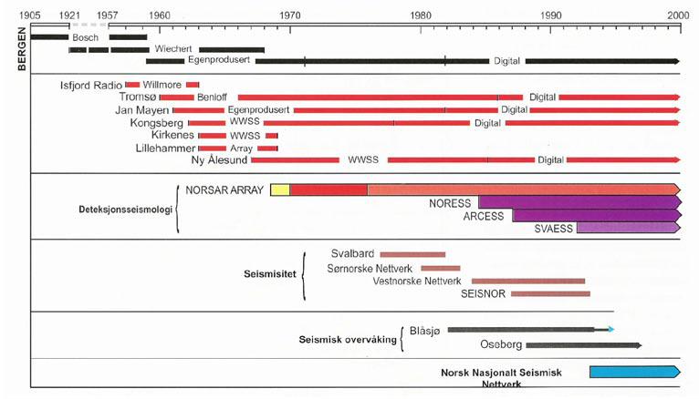
Figure 1. History of seismic stations in Norway.
While most seismic stations in Norway are operated to monitor earthquake activity, the main purpose for the seismic stations on Jan Mayen is to monitor the active volcano. The eruptions in 1970 and 1985 were reminders of Jan Mayen being active. The eruption in 1970 was the reason to establish a three station seismic network on the island, which happened in 1972. Prior to that, there had only been one station, which is insufficient to locate earthquakes. The seismic network on Jan Mayen is used both to record earthquakes nearby, which can be significant and above magnitude 6, and to monitor for seismic events at the volcano, which are expected prior to and during a volcanic eruption.

Current status
The overall purpose of the network is to provide data both for scientific studies, but equally important for the routine observation of earthquakes. The NNSN consists of 32 single seismic stations that are operated by UiB that monitor the seismic activity in Norway and the adjacent offshore areas. The stations are distributed over the entire country including Svalbard, Bjørnøya, Hopen and Jan Mayen (Figure 1). In addition data from stations operated by NORSAR and institutions outside Norway are included in the data processing. The NNSN is operated by the UiB in collaboration with NORSAR, and with funding from the OLF.
The NNSN is a modern seismic network with real-time communication to all stations. Data are transferred to the centre at the University of Bergen continuously for data processing and archiving. Communication is done through Internet, ADSL, mobile phone and satellite links. The network is presently being upgraded from short-period seismometers to broadband seismometers, and to the same type of acquisition system at most sites. At the time of writing, 15 of the 29 sites are equipped with high quality broadband seismometers.
Over the last decade the network configuration has been rather stable, but a few stations have been added, and some have been closed down (Figure 4, Table 1). Overall, the detection level is better than magnitude 2 on land and better than 2.5 offshore (Figure 3). The detection map was calibrated against the database of detected events. However, as detection depends on noise conditions it may be slightly worse at times. The main limitation continues to be the poorer detection offshore, which can only be avoided by the use of seismometers offshore.
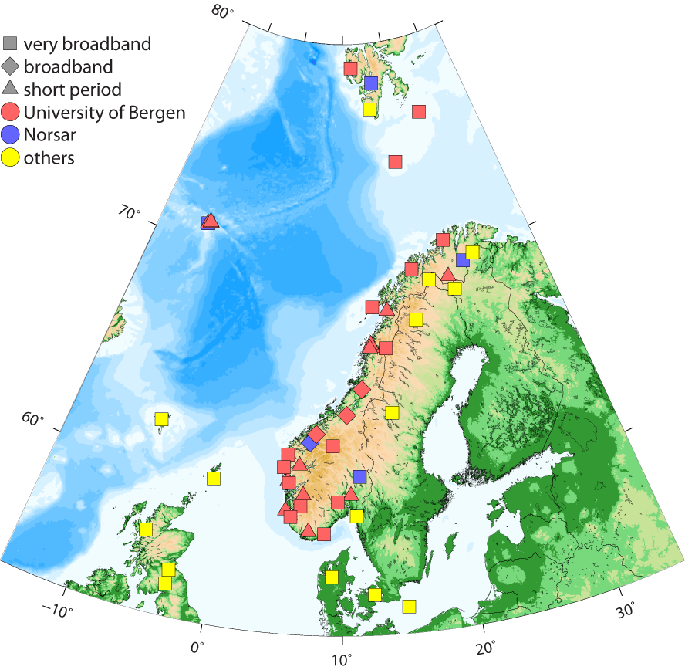
Figure 2. Stations used within the NNSN, January 2013.
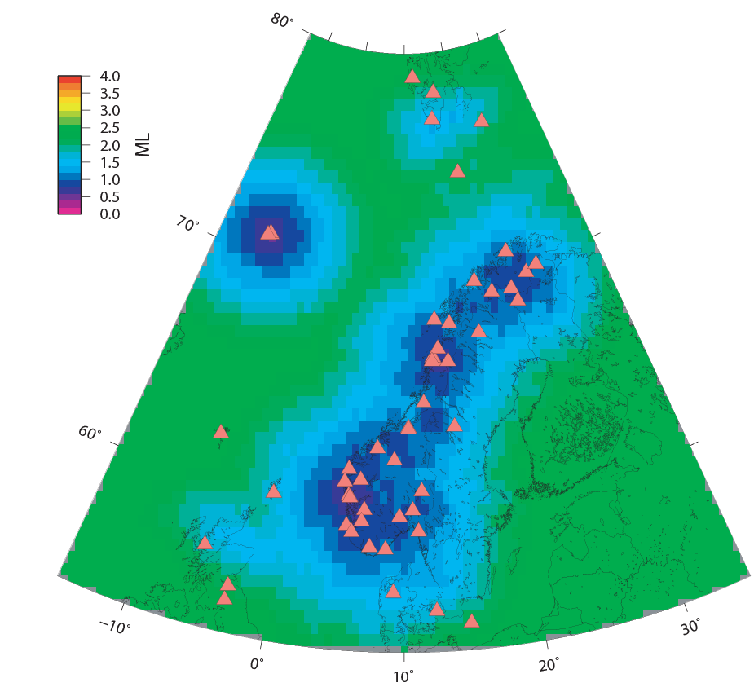
Figure 3. Computed detection levels giving expected smallest magnitude to be detected by the NNSN network as of 2012 (seismic arrays are not considered).

Table 1. Seismic stations and arrays in Norway in the period 2001-2010. The abbreviation ‘BB start’ refers to the date of broad band seismograph installation.

Name | Code | Latitude | Longitude | Alt. (m) | Start | BB start | Closed
Askøy | ASK | 60.483N | 5.195E | 50 | 1982
Bergen | BER | 60.384N | 5.334E | 50 | 1905 | 29.sep.2004
Bjørnøya | BJO1 | 74.506N | 19.188E | 18 | 1990 | 18.sep.2005
Blussuvoll | TBLU | 60.419N | 10.434E | 232 | 2008 | 15. Dec. 2008
Blåsjø | BLS5 | 59.423N | 6.456E | 540 | 1983 | 20. may.2010
Dombås | DOMB | 62.073 | 9.112 | 660 | 2002 | 27. oct 2010
Espegrend | EGD | 60.188N | 5.226E | 20 | 1991 | - | feb.2010
Flostrand | FLOS | 66.336 | 13.363 | 18 | 2005
Florø | FOO | 61.598N | 5.044E | 15 | 1983 | 07.feb.2008
Hammerfest | HAMF | 70.642N | 23.684E | 105 | 2010 | 10 June 2010
Homborsund | HOMB | 58.270N | 8.505E | 21 | 2008 | 21.nov.2008
Hopen | HOPEN | 76.508N | 25.010E | 25 | 2004 | 03. Dec. 2007
Høyanger | HYA | 61.166N | 6.187E | 30 | 1985
Jan Mayen | JMI | 70.928N | 8.731W | 211 | 1961
Jan Mayen | JNW | 70.990N | 8.297W | 57 | 1972
Jan Mayen | JNE | 71.029N | 8.428W | 95 | 1972
Karmøy | KMY | 59.212N | 5.247E | 58 | 1984
Kautokeino | KTK1 | 69.116N | 23.237E | 340 | 1986 | 23.sep.2007
Kongsberg | KONO | 59.649N | 9.598E | 216 | 1962
Konsvik | KONS | 66.499N | 13.117E | 23 | 2005
Lofoten | LOF | 68.126N | 13.538E | 80 | 1986 | 11. May 2011
Meløy vg. skule | MELS | 66.939N | 13.723E | 19 | 2004 | - | Dec. 2005
Mo i Rana | MOR | 66.286N | 14.735E | 445 | 1987 | 20. June 2011
Molde | MOL | 62.569N | 7.542E | 98 | 1986 | 04.mai.2006
Namsos | NSS | 64.525N | 11.967E | 102 | 1986 | 05.feb.2002
Ny Ålesund | KBS | 78.919N | 11.924E | 46 | 1967
Odda | ODD1 | 59.912N | 6.628E | 684 | 1984
Oslo | OSL | 59.937N | 10.723 | 70 | 2000
Rundemannen | RUND | 60.414N | 5.367E | 525 | 1997 | - | nov.2010
Snartemo | SNART | 58.3532 | 7.206 | 160 | 2003
Stavanger | STAV | 58.935 | 5.702E | 28 | 2001 | 08.nov.2011
Steigen | STEI | 67.930N | 15.242E | 21 | 2007
Stokkvågen | STOK | 66.333N | 13.018 | 32 | 2003
Sulen | SUE | 61.057N | 4.761E | 10 | 1984 | 02.apr.2009
Tromsø | TRO | 69.633N | 18.928E | 15 | 1960 | 26.mar.2003
Trondheim | TRON | 63.454N | 10.436E | 34 | 1997 | - | 7 may 2006

Figure 4. Time chart of stations operated by UiB since 1990.
The operation and data analysis of the NNSN are based on software developed internally at UiB, but also external software. On the field stations the data acquisition is done through the SEISLOG software (Utheim et al., 2001). The data transfer is done through a SEEDLINK server on the station, and a SEEDLINK client at the centre (). The automated central processing is done with the EARTHWORM software (). Data files are prepared for the data processing by the SEISNET software (Ottemöller and Havskov, 1999). The interactive analysis is done through the SEISAN package (Havskov and Ottemöller, 1999). A change during this decade was that now continuous data are stored from all stations. Data from most stations are available since 2008, from some stations from as early as 2000.

Earthquake analysis
Data from the NNSN are used to detect and process earthquakes within the region defined by the coordinates 54-82°N and 15°W-32°E. In addition, data is used from neighbouring networks. The primary sources for additional data are NORSAR, which provide seismic data from the NORSAR arrays and other array data processed by NORSAR (Apatity, Fines and Hagfors, located in Russia, Finland and Sweden respectively), the British Geological Survey (BGS) and the Geological Survey of Denmark and Greenland (GEUS).
The data processing starts with manual inspection of the seismograms to identify true seismic events from noise signals. Seismic events are processed in detail, involving the reading of seismic arrival times and amplitudes, which are used for computation of the hypocentre and magnitude, respectively. The seismograms are also checked to distinguish earthquakes from explosions when possible. In addition to the visual checks by the data analysts, an explosion filter (Ottemöller, 1995) is applied, which identifies likely explosions by requiring an even time of day distribution as explosions are often carried out at a similar time of day at individual sites. However, not all explosions can be detected this way, and it is also possible that earthquakes are wrongly classified as likely explosions.
Monthly bulletins are issued containing data from both the NNSN and other networks. The monthly bulletins are sent to national and international agencies, such as the European Mediterranean Seismological Centre (EMSC) and the International Seismological Centre (ISC). Further processing using SEISAN is performed regularly for various research tasks or for special interesting events. All results are stored in the NNSN database, which is also available to the public.
The velocity models used for location and magnitude scales used are published with the monthly bulletins.
In addition to instrumentally recorded events, the database also contains information about felt earthquakes. These macroseismic data have been collected continuously in Bergen since the 1880s, and earlier data has been included from historical information. However, the database contains mainly earthquake information starting from year 1900.

Explosions
The number of explosions detected by the NNSN is greater than the number of local earthquakes. Figure 5 shows the locations of explosions and earthquakes. Explosions are identified by the NNSN in the following ways: 1) they are confirmed by who carried out the explosion, 2) the seismic analyst decides based on the signal characteristics and/or location and time, and 3) indicated as likely explosions by a filter that has been in use since 1995 (Ottemöller, 1995). The filter ignores the signals and only tries to reach a uniform time of day distribution. This means that earthquakes can be wrongly labelled as likely explosions.
There are some clear clusters of explosions (Figure 5) which correspond to mining locations. However, the situation is more complicated along the south-western coast, where explosions are generally not clustered and also overlap with earthquake activity.
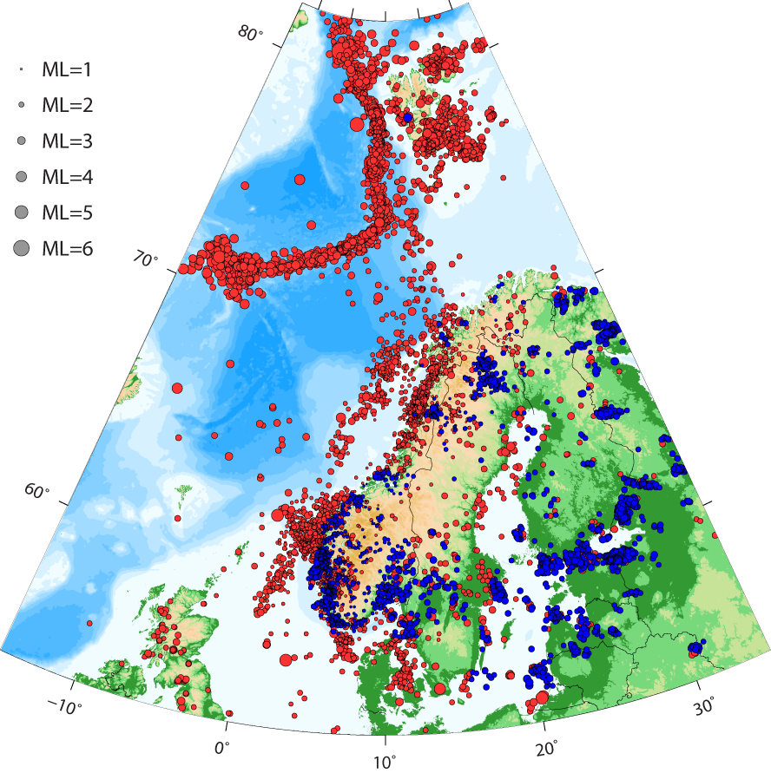
Figure 5. Map of earthquakes (red) and explosions (blues) in the period 2001-2010.

Seismicity

Overview
Seismicity levels in mainland Norway are low to intermediate and earthquakes are of intraplate origin (Bungum et al, 1991). The largest earthquakes in mainland Norway were of ML=5.8 on 31 August 1819 near Lurøy, Northern Norway (Bungum and Olesen, 2004) and ML=5.4 in the Oslofjord on 23 October 1904. More recently, an intraplate earthquake of MW=6.0 occurred in the Storfjorden area southeast of Spitsbergen on 21 February 2008. Otherwise, the largest earthquakes near Norway occur along the Mid-Atlantic ridge plate boundary. Here, an earthquake of MW=6.5 occurred on 6 March 2009 northwest of Spitsbergen. Significant earthquakes also occur on the Jan Mayen fracture zone north of Jan Mayen. Recent examples are the MW=6.6 earthquake on 31 August 2012, the ML=6.0 earthquake on 29 January 2011, the MW=6.0 on 14 April 2004 and the mb=5.7 occurred on 13 December 1988.
The pattern of seismicity in Norway is somewhat diffuse, but most of the seismicity is confined to well defined areas (Bungum et al., 1991). Bungum et al. (1991) divide Norway into three areas from South to North. Much of the offshore seismicity in the southern part falls into the Central and Viking Graben areas, and some seismicity falls into the Norwegian-Danish Basin. However, most active are the coastal areas between 59° and 63°N, where three moderate size earthquakes were observed. These occurred on 5 February 1986 (MS=4.9), on 8 August 1988 (MS=5.3) and on 23 January 1989 (MS=5.1). In the middle part between 63° and 70°N, the seismicity falls into two branches, one following the coastline and the other the continental margin to the west. The Lurøy earthquake falls into this second area. Further north, in area three the seismicity is more diffuse with seismicity limited in a zone of weakness parallel to the shelf edge between Norway and Svalbard. Around Svalbard, the Storfjorden area has become the most active zone since the MW=6.0 event in 2008. However, moderate size earthquake had previously occurred around Heer Land.
While the possible causes for earthquakes in Norway are known, it is difficult to pinpoint the exact cause of an individual earthquake, and often a combination is the only way to explain. The main sources generating stresses that result in earthquakes are the ridge-push force from the Mid-Atlantic ridge, lithospheric loading and unloading due to sediments or glaciation (Bungum et al, 1991; Bungum et al., 2010). These plate-wide stresses are usually overprinted by regional and local stress perturbations. Geological structures such as faults act as the zones of weakness where earthquakes repeatedly occur. While the pattern of source mechanisms is rather complex a general trend appears to be that oceanic earthquakes are predominantly reverse-oblique, while continental seismicity is mostly oblique-normal (Bungum et al, 1991; Hicks and Lindholm, 2000).

Seismicity this decade
The number of seismic events divided into local/regional, distant (epicentral distance of more than 3000 km), and probable/confirmed explosions located by the NNSN are shown in Figure 6. The total of all located events during 2001-2010 is over 30000, of which 12543 are local/regional earthquakes, 8592 are teleseismic earthquakes and 9185 are explosions. The database contains an additional 14000 explosions that were detected, but not located. The yearly number of local/regional earthquakes undergoes changes, which are typically related to specific earthquake sequences, such as the large events with aftershocks in Jan Mayen and Storfjorden in 2004 and 2008, respectively. Swarm activity like in the Steigen area in 2008, and changes in the activity in the Rana area also result in increased yearly numbers.
Figure 6. Number of local, distant and likely/confirmed explosions, respectively.

Local earthquakes
The locations of all earthquakes this decade are plotted in Figure 7 and for magnitude larger than 3 in Figure 8. The general distribution is as expected and previously observed. The only exception is the increased activity in Storfjorden since 2008. The most active regions otherwise were the Mid-Atlantic ridge, the two branches offshore northern Norway, the offshore and coastal areas in south-western Norway, and the Norwegian-Danish basin. Figure 8 shows that only one earthquake with magnitude greater than 4 occurred in mainland Norway.
Looking at the magnitude distribution of earthquakes (Figure 9) it is seen that the catalogue is approximately complete down to magnitude 2.5. However, as shown in Figure 3 the detection threshold varies laterally, and the catalogue for the mainland is probably complete to magnitude 2.
The total of earthquakes that were felt this decade was 122. Their locations and distribution over time are given in Figure 10 and Figure 11, respectively. Most of the events were felt along the coast in the regions of relatively high activity both in the south and north. In addition, two of the larger events were felt on oil platforms (Ekofisk 2001 and Statfjord 2007). A number of moderate and large magnitude earthquakes were felt on Jan Mayen. The large earthquakes in Storfjorden were felt on Spitsbergen.
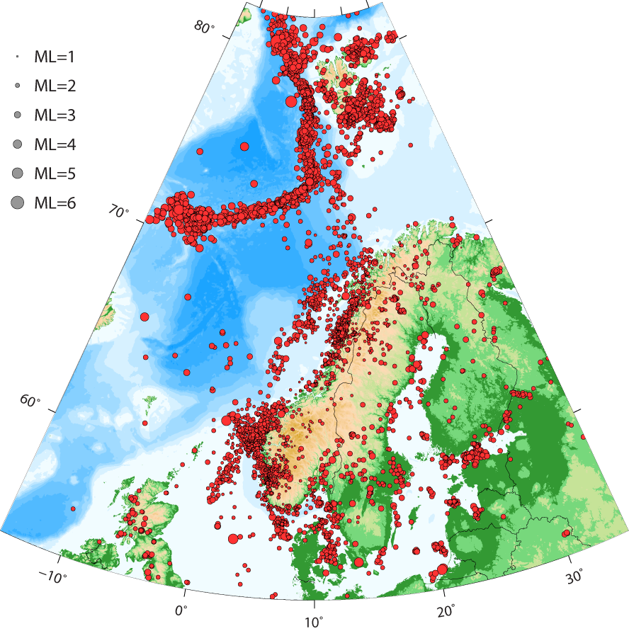
Figure 7. Map of earthquakes in the NNSN database in the period 2001-2010.
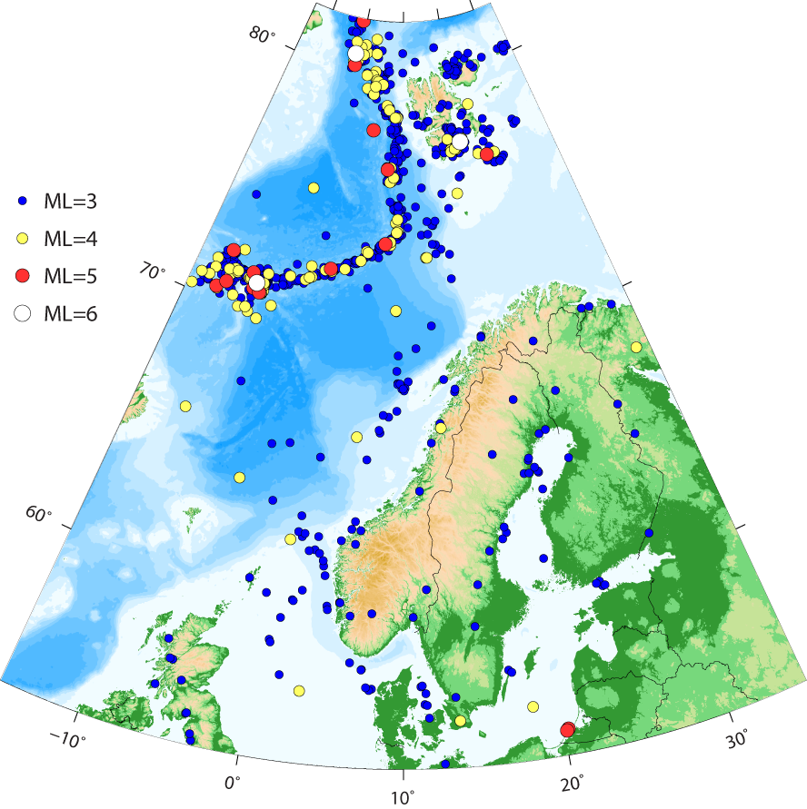
Figure 8. Map of earthquakes above magnitude 3 in the NNSN database in the period 2001-2010.
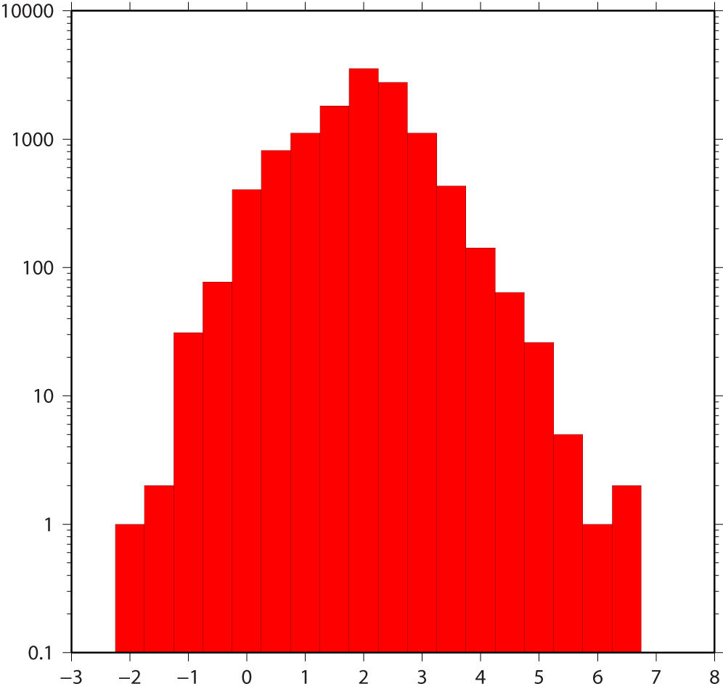
Figure 9. Magnitude distribution of earthquakes during the period 2001-2010.
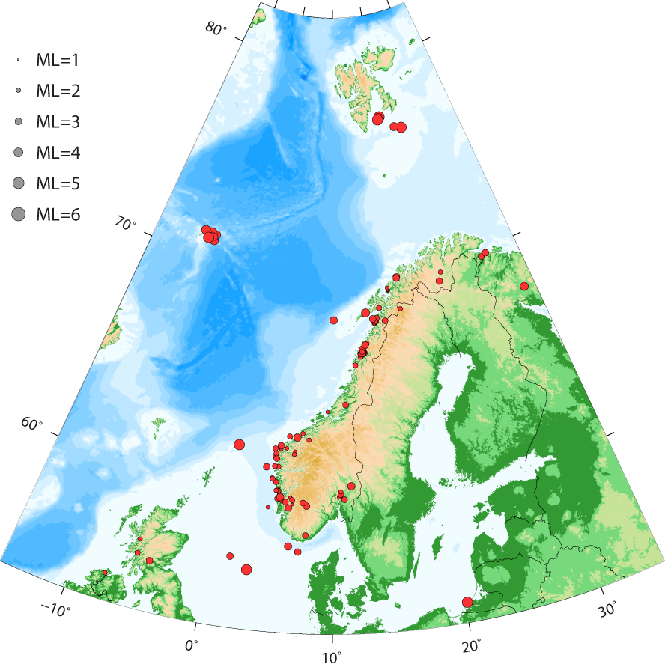
Figure 10. Map of earthquakes felt in the NNSN database in the period 2001-2010.

Figure 11. Yearly number of earthquakes that were felt in Norway.

Teleseismic earthquakes
The total of distant earthquakes that are included in the NNSN database is about 800 per year. The locations are plotted in Figure 12. Distant earthquakes in the NNSN database are detected by the NNSN, the NORSAR array, or both. An attempt is always made to locate the earthquakes with the Norwegian stations. However, if that result is not satisfactory, the earthquake location is fixed to that published by the USGS. Nevertheless, although the NNSN is not well suited for locating global seismicity, a reasonably good location is obtained in many cases. Most importantly, the phase data from these earthquakes goes to the international data centres and gets used for scientific studies of the Earth’s structure. Figure 13 presents the global detection capability based on events in the NNSN database. This shows that for most parts of the world the average magnitude is about 5.5. For some regions the detection is better, for example earthquakes down to magnitude 5 are detected in North America. In southern Europe, North Africa, the Middle East, western Asia, the average detection is magnitude 5, but earthquakes down to magnitude 4 can be observed. For parts of Indonesia, Japan and Eastern Russia, the smallest detected events go down to magnitude 5 (minimum magnitude) or even 4.5. The yearly numbers of distant earthquakes are shown in Figure 14. The changes seen can be related to the occurrence of great earthquakes (e.g., Sumatra 2004) that come with a large number of aftershocks.
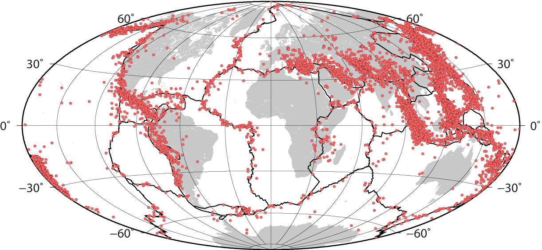

Figure 12. Map of distant earthquakes in the NNSN database in the period 2001-2010. Earthquakes that are marked as local and regional are not plotted.
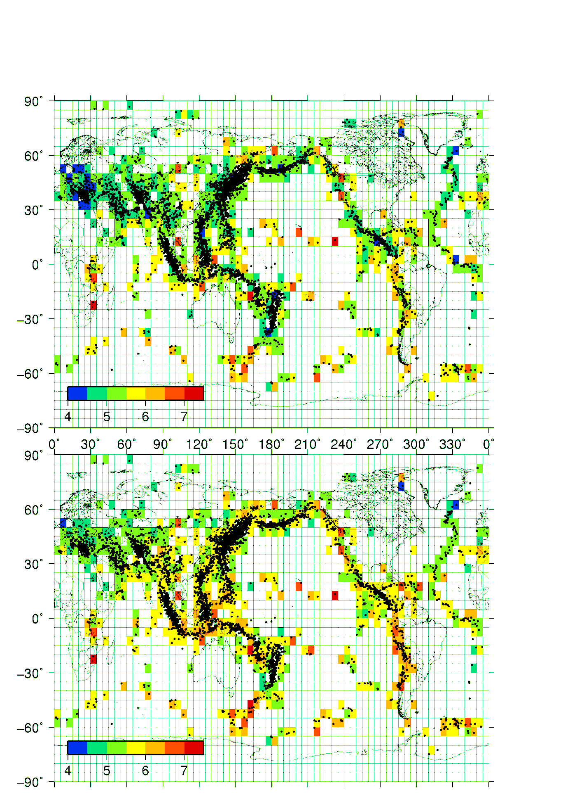
Figure 13. Global detection capability, where the colour code presents the minimum (top) and average (bottom) magnitudes in 5x5 degree grid cells. The data were selected for earthquakes with at least three stations.

Figure 14. Yearly number of teleseismic earthquakes in the NNSN database.

Significant earthquakes this decade
During this decade quite a number of significant earthquakes have occurred in terms of size or importance. The Storfjorden earthquake in 2008 serves as a reminder that relatively large intraplate earthquakes can occur in the wider region, including mainland Norway.

Ekofisk 2001
A seismic event was strongly felt on the platforms within the Ekofisk field, offshore Norway, on 7 May 2001 at 09:43. The event was initially located near the Ekofisk field and due to this proximity became subject of several studies (Ottemöller et al., 2005; Selby et al., 2005; Cesca et al., 2011). In addition, the operator of the Ekofisk field ConocoPhillips carried out extensive investigations into the causes of the event. The final conclusion was that the event occurred at shallow overburden depth within the reservoir outline and was induced through unintentional water injection. The moment magnitude was found to be in the range 4.1-4.4 (Ottemöller et al., 2005).
Figure 15 shows the epicentre location of the event which was determined at 56.567°N and 3.179°E with horizontal errors of about 5 km (Ottemöller et al., 2005). The hypocentre depth was estimated to be shallow from the earthquake location procedure and moment tensor inversion and later considered to coincide with unintended water injection into the overburden at about 2 km depth. The event was confined to the overburden as production was not disturbed by the event. The pressure was high enough to result in an uplift of the overburden over a relatively wide area indicating mostly horizontal propagation of the injected water (Figure 16). The resulting over-pressure is considered to have facilitated the movement that took place during the seismic event. The source spectra were used to measure stress drop, which was found to be relatively low (Ottemöller et al., 2005) supporting the idea of a shallow relatively large source with a radius of 1-4 km. GPS data and macro-seismic observations at Ekofisk supported the understanding of the source being at Ekofisk.
Figure 15. Regional (left) and local (right) overview of location (from Ottemöller et al., 2005).

The mechanism was determined through regional moment tensor inversion and found to be near horizontal. Later studies by Selby et al. (2005) and Cesca (2011) also discuss the result of moment tensor inversion showing near-horizontal slip, but with a different direction of slip. These two studies considered the relatively low velocities in the source region and their result is therefore probably more correct. The estimated source dimensions and GPS observations in the centre of the field support the hypothesis that a larger part of the area was affected by the event.
Cesca et al. (2011) attempted to consider both seismic and GPS data in the source inversion. Based on the GPS data they place the centre of moment release at the eastern border of the field (Figure 17). Finding NW to SE unilateral rupture direction from the seismic data, they suggest rupture initiation near the injection well, rupture propagation along a near horizontal surface and main moment release near the eastern border of the reservoir.
The causes and processes of the source combined with the size made this a unique event, and perhaps the most significant seismic event in Norway during this decade. It also demonstrated the importance of the seismic network in Norway.
Figure 16. Differential bathymetry map over Ekofisk comparing 1999 and 2001. The red colour in the North shows the uplifted area due to unintentional water injection (from Ottemöller et al., 2005).
Figure 17. GPS data puts main moment release at eastern edge of the reservoir (from Cesca et al., 2011).

Hopen 2003
An earthquake was felt on Hopen Island on 4 July 2003. The earthquake was located offshore, west of Hopen at 76.494°N and 23.872°E with an origin time of 07:16:48.1. The event depth was fixed to 10 km. Details of the analysis were given in Sørensen et al. (2003). The magnitudes of the earthquake were MW=5.4 (global CMT catalog) and ML=4.9 (NNSN). A number of earthquakes occurred in the broader area within a few days of the main event (Sørensen et al, 2003).The mechanism determined using global data (global CMT catalog) was strike=278, dip=38 and slip=-101, indicating mostly normal faulting (Figure 18) with minimum compressive stress in north-south direction. This is similar to the stress direction inferred for an earthquake in the Heer Land area of Svalbard in 1976 (Bungum, 1976), and also the Storfjorden earthquake in 2008 (Piril et al., 2010) (Figure 18).
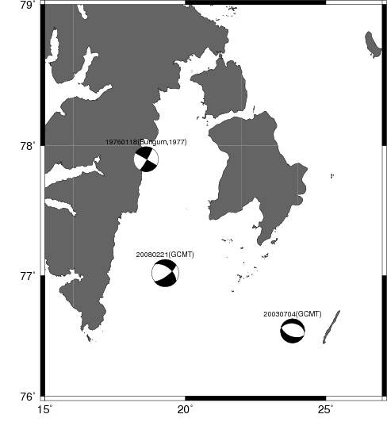
Figure 18. Fault plane solutions for three earthquakes in the Svalbard region. The solution for the Heer Land event is taken from Bungum (1977), while the other two are from the global CMT catalogue.

Jan Mayen 2004
An earthquake of MW=6.0 occurred within the Jan Mayen Fracture Zone on 14 April 2004 at 23:07. The earthquake was felt on Jan Mayen at a distance of about 50 km. The earthquake and its recorded aftershocks were studied in detail and interpreted in relation to the bathymetry by Sørensen et al. (2007). The earthquake was located in the Jan Mayen Fracture Zone that connects the Kolbeinsey ridge to the south-west and Mohns ridge to the north-east of Jan Mayen. The fracture zone itself has a WNW-ESE orientation and passes north of Jan Mayen. The fault mechanism as determined by the Global CMT catalogue is consistent with a left-lateral strike slip mechanism expected for large events in the fracture zone. The mainshock was associated with the Koksneset fault that was probably also the source of a similar size event in 1988. A total of 110 aftershocks were detected with ML>2.7 (Sørensen et al., 2007). The largest aftershock on 15 April 2004 at 01:11 had a magnitude of M=4.0. While most of the early aftershocks were associated with the main fault, two distinct clusters of seismicity developed later (Sørensen et al., 2007) thought to be normal faulting events linked to east-west extension (Figure 19).
Figure 19. Comparison of manual locations (a) with relative relocations also showing clusters with similar waveforms (b) (from Sørensen et al., 2007).

Northern North Sea 2007
On 7 January 2007, an earthquake occurred in the northern North Sea. The earthquake was located at 61.991°N, 1.120°E at 01:50 and had a magnitude ML=4.8 (BGS). The earthquake was reported felt by people on the Shetland Islands and by one person in western Norway. The earthquake was also felt at the Statfjord oil platform. The reported macroseismic description of the earthquake corresponds to an intensity of IV (European Macroseismic Scale, Grünthal 1998). The regional moment tensor inversion shows NE trending reverse faulting which is in line with the general stress tensor in the region.

Svalbard 2008
At 02:46 (UTC) on 21 February 2008, a magnitude 6.0 (M_{W}) earthquake occurred in Storfjorden, Svalbard, approximately 155 km south east of Longyearbyen. The earthquake was strongly felt in Longyearbyen and is the largest intraplate earthquake recorded on Norwegian territory. The mainshock was followed by a large number of aftershocks, which are still on-going in 2012 (Figure 20). The total number of events in the area since 21 February 2008 until December 2012 has been 935, with 20 of them above magnitude 4.0. The earthquake and the early aftershocks were presented by Piril et al. (2010).
For the largest events in the sequence, the fault plane solution was determined through regional moment tensor inversion. Figure 21 gives an example for the largest of the events. The moment tensor inversion uses waveform data in the frequency band 0.01 to 0.1 Hz, which means that the seismograms are dominated by surface waves. Solutions for the smaller events are shown in Figure 22. The inversion for the smaller events is based on fewer stations, but the solutions are still quite robust. The alignment of the larger events matches that of the complete sequence, with a linear trend in SW-NE direction. This direction matches one of the two nodal planes, and it is likely that this direction shows the causative fault. This normal faulting structure connects two major fault structures that run in NS direction.
The earthquake sequence provided useful ground motion observations (Figure 23) as large earthquakes on mainland Norway are not frequent. An interesting observation made is that the magnitude 6 event had in comparison to empirical relationships the largest values. This can be explained by this event having a higher stress drop than the smaller events. While an interpretation of these data is still going on, having higher stress drop for the potentially largest earthquakes has an impact on the seismic hazard maps.

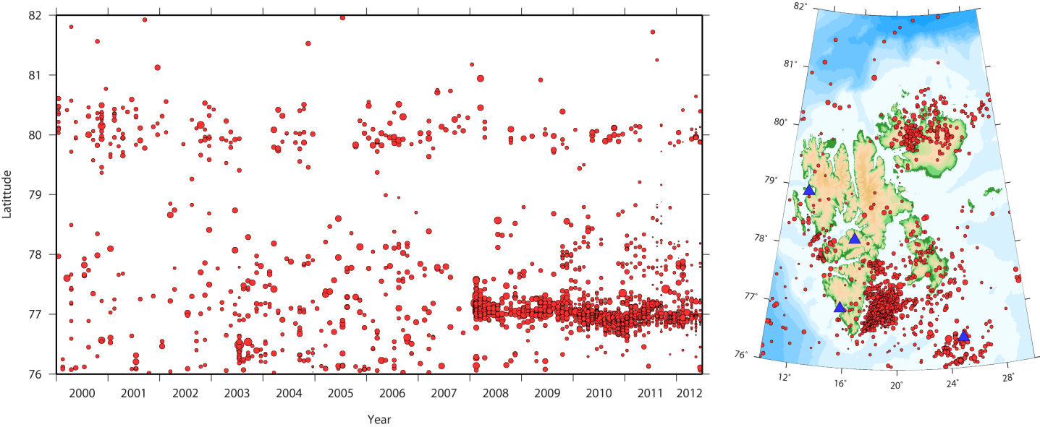
Figure 20. Svalbard seismicity: distribution given by latitude over time (left) and map view (right).

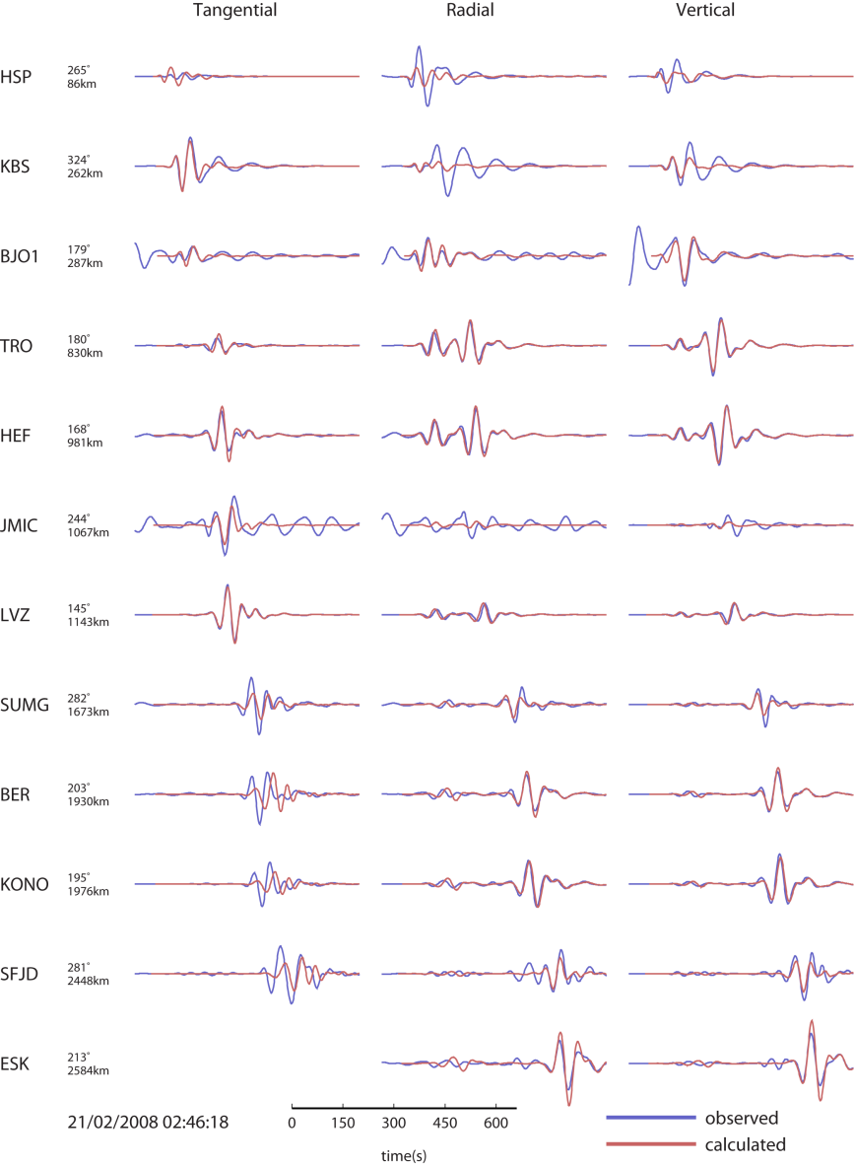

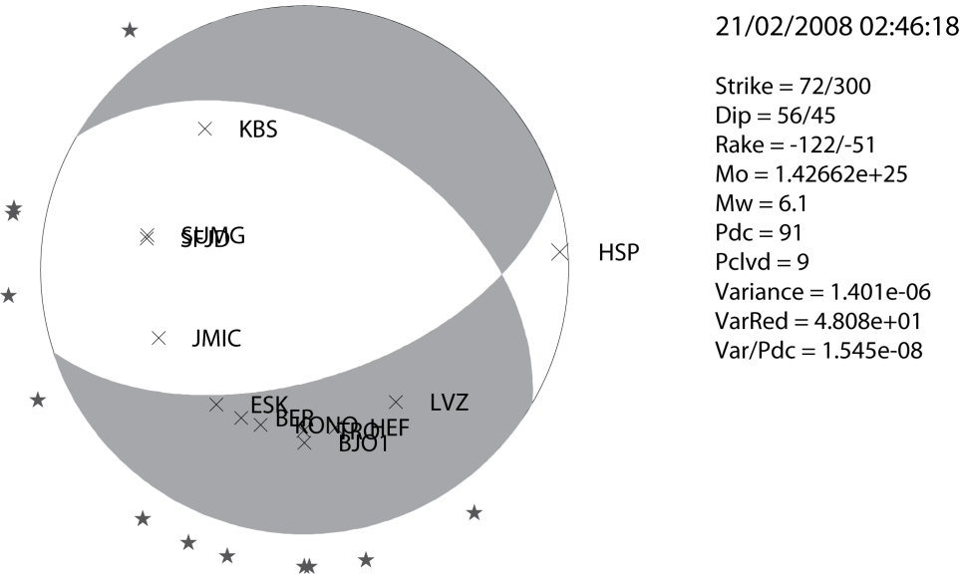

Figure 21. Result from moment tensor inversion for the MW=6.1 event on 21 February 2008, comparison between observed and computed seismograms (bottom) and double couple focal mechanism solution (bottom).

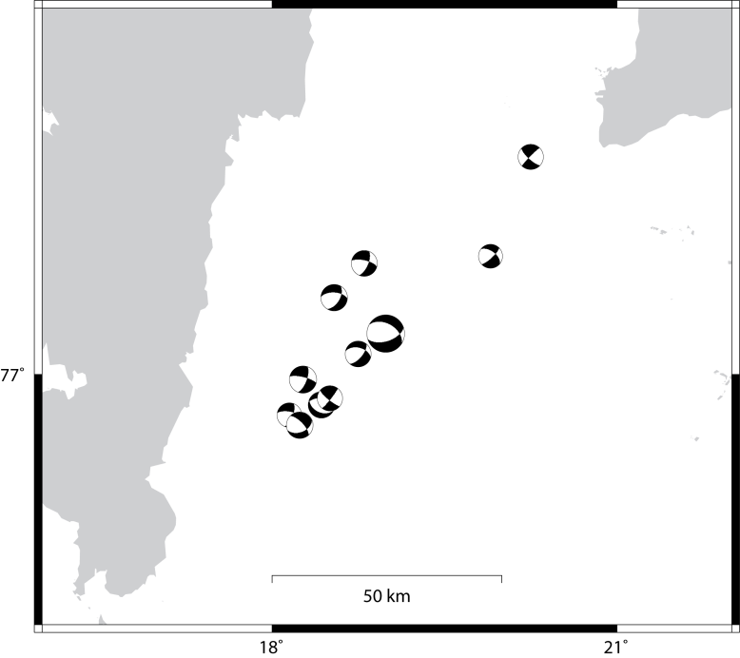
Figure 22. Focal mechanism plots obtained through moment tensor inversion for the largest earthquakes in the sequence.

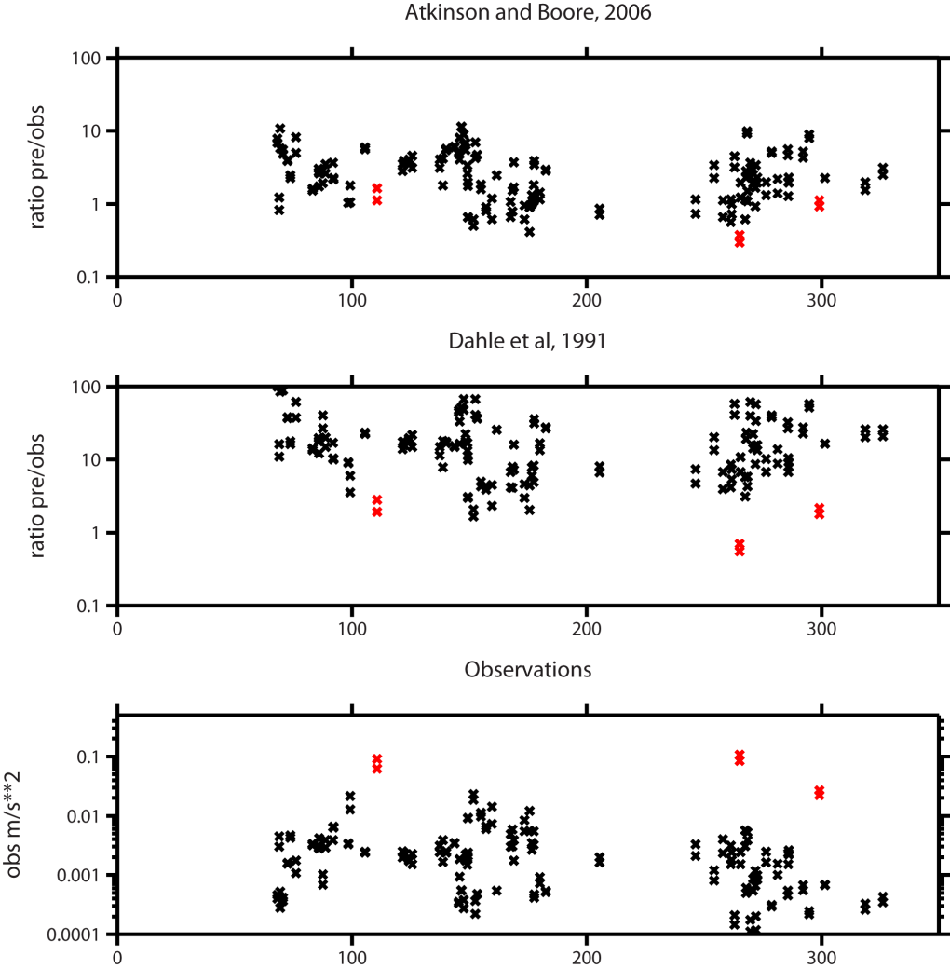
Figure 23. Peal ground accelerations observed for the largest earthquakes in the sequence (bottom), and comparison with two ground motion relationships (top and middle). The observations from the 21 February 2008 event are shown in red.

NW Svalbard 2009
At 10:50 (UTC) on 06th March 2009 a magnitude 6.5 (M_{W} GCMT) earthquake occurred northwest of Svalbard. This was the largest earthquake close to the Norwegian territory ever recorded by the Norwegian seismic stations. The closest seismic station was located in Ny Ålesund (KBS) at 323 km distance. During 2009 only few earthquakes were located in the vicinity of the March earthquake as smaller aftershocks would not be detected. The mechanism of the event was strike-slip with a normal component as given by the Global CMT catalogue (http://www.globalcmt.org).

Scientific use of the data
Looking back at the last decade the NNSN data have been the basis for a significant number of scientific studies. The data have been used both in studies of seismicity as well as the Earth interior. Scientific progress was possible due to new data and events, improved data, the continuous storage of data as well as development of new techniques. Many of the resulting papers on seismicity have been cited in the previous section on ’Significant earthquakes this decade’. The main events were Ekofisk in 2001 (Ottemöller et al., 2005), Jan Mayen in 2004 (Sørensen et al., 2007) and Storfjorden in 2008 (Pirli et al., 2010). This section will also give a brief summary of studies investigating the Earth’s crust and upper mantle beneath mainland Norway using temporary deployments. The list given is by no means complete.
Two profiles of temporary seismic instruments were deployed between 2002 and 2005, from Ålesund and Bergen towards Hamar, respectively. Svenningsen et al. (2007) used data from these profiles to estimate receiver functions and from that to present migrated images. They find a 10-12 km thick root under the areas with the highest surface elevations. Their crustal thicknesses compare well to earlier results by Ottemöller and Midzi (2003) for comparable sites. The study by Bondo Medhus (2009) used teleseismic data from this experiment to investigate deep structures in south-western Scandinavia from travel time residuals. They found evidence for positive residuals beneath southern Norway, but cannot conclude that this slow body is responsible for the observed surface topography.
The MAGNUS experiment in southern Norway was carried out between 2006 and 2008 with a total of 41 seismic stations (Weidele et al., 2010). This project was carried out under “TopoScandiaDeep—the Scandinavian Mountains: Deep Processes” with the main objective to investigate the lithosphere and asthenosphere under southern Norway. It was hoped that the Earth images obtained could shed light on the causes of the mountains in this region. Analysis of the MAGNUS data has shown that in southern Norway the lithosphere is underlain by hotter and slower material that may be responsible for the mountain building (Maupin, 2011). The data was also used by Köhler et al. (2011) to measure surface wave group velocities from ambient noise data. Linked to MAGNUS, three refraction profiles were done in Southern Norway in 2007. From this, a Moho map was presented (Stratford et al., 2009; Stratford and Thybo, 2011).
Further north, the SCANLIPS deployments were used to compute receiver function images (England and Ebbing, un published).
The causes of earthquakes remain only partly understood. Out of the various options, postglacial rebound is now considered a minor factor (Bungum et al., 2010). Plate wide compression appears to be the main driving force, with local stress changes due to load changes also being of significance.

Outlook
The end of this decade coincides with the start-up of EPOS (European Plate Observing System), a Europe-wide project to link and build monitoring systems long-term. In Norway, it is planned under EPOS to improve both seismological and geodetic monitoring and achieve better access to integrated data. This would help to better image the Earth structure beneath Norway and obtain denser and higher quality recordings of earthquakes. Both would help to better understand the causes of earthquakes in and around Norway resulting in an improved understanding of seismic hazard. Through EPOS, the NNSN could grow by about 10 stations.
During this decade, a number of seismic stations have been improved by installing broadband seismometers and/or quality digitizers. This process will continue. Further improvement is possible by better vault construction, this will be a priority for the coming decade.
Models used for routine processing have not been improved for 20 years. With the new NNSN contract starting in 2013 it is planned to improve models for velocity, attenuation and magnitude scales. This will lead to better results for the location of earthquakes and their source parameters.

References
Bungum, H. Two focal-mechanism solutions for earthquakes from Iceland and Svalbard, Tectonophysics, 41, 15-18, 1977.
Bungum, H., A. Alsaker, L. Kvamme, and R. Hansen, Seismicity and Seismotectonics of Norway and Nearby Continental Shelf Areas, J. Geophys. Res., 96, B2, 1991.
Bungum, H. and O. Odleiv. The 31st of August 1819 Lurøy earthquake revisited, Norwegian Journal of Geology, Vol. 85, pp. 245 – 252, 2004.
Bungum, H., O. Olesen, C. Pascal, S. Gibbons, C.Lindholm and O. Vestøl, To what extent is the present seismicity of Norway driven by post-glacial rebound? Journal of the Geological Society, London, 167, 2010, 373–384, 2010.
Cesca, S., T. Dahm, C. Juretzek and D. Kühn. Rupture process of the 2001 May 7 M_{w} 4.3 Ekofisk induced earthquake, Geophysical Journal International, 187, 407–413, 2011.
Havskov, J. and L. Ottemöller, 1999. SEISAN earthquake analysis software, Seism. Res. Letters, Vol. 70, pp. 532-534.
Hicks, E., H. Bungum and C. Lindholm, Stress inversion of earthquake focal mechanism solutions from onshore and offshore Norway, Norsk Geologisk Tidsskrift, 80, 235-250, 2000.
Köhler, A., C. Weidle and V. Maupin. Directionality analysis and Rayleigh wave tomography of ambient seismic noise in southern Norway, GJI, 184, 287–300, 2011.
Bondo Medhus, A., Balling, N., Holm Jacobsen, B., Kind, R. & England, R. W. Deep-structural differences in southwestern Scandinavia revealed by P-wave travel time residuals. Norwegian Journal of Geology, vol. 89. pp. 203-214, 2009.
Ottemöller, L. Explosion filtering for Scandinavia. NNSN technical report, University of Bergen, Norway. 209 pp, 1995.
Ottemöller,L. and J. Havskov, 1999. SEISNET: A general purpose seismic network, Seism. Res Letters, Vol. 70, pp. 522-528.
Ottemöller, L., H. H. Nielsen, K. Atakan, J. Braunmiller, J. Havskov. The 7 May 2001 induced seismic event in the Ekofisk oil field, North Sea, J. Geophys. Res., Vol. 110, No. B10, B10301, 2005.
Ottemöller, L. and V. Midzi, The crustal structure of Norway from inversion of teleseismic receiver functions. J. of Seismology, 7, 35–48, 2003.
Maupin, V. Upper-mantle structure in southern Norway from beamforming of Rayleigh wave data presenting multipathing, GJI, 185, 985–1002, 2011.
Pirl, M.i, J. Schweitzer, L. Ottemöller, M. Raeesi, R. Mjelde, K. Atakan, A. Guterch, S. J. Gibbons, B. Paulsen, W. Debski, P. Wiejacz, and T. Kværna. Preliminary Analysis of the 21 February 2008 Svalbard (Norway) Seismic Sequence, Seismological Research Letters 81(1): 63-75, 2010.
Selby, N. D., E. Eshun, H. J. Patton, and A. Douglas. Unusual long-period Rayleigh wave radiation from a vertical dip-slip source: The 7 May 2001 North Sea earthquake, J. Geophys. Res., 110, B10304, 2005.
Svenningsen, L., N. Balling, B. H. Jacobsen, R. Kind, K. Wylegalla and J. Schweitzer. Crustal root beneath the highlands of southern Norway resolved by teleseismic receiver functions Geophys. J. Int., 170, 1129–1138, 2007.
Sørensen Bøttger, M., A. Fettig and J. Havskov. The July 4th 2003 Svalbard earthquake, Univ. of Bergen, NNSN Tech. Report, 14, 2003.
Sørensen Bøttger, M., L. Ottemöller, J. Havskov, K. Atakan, B. Hellevang and R. B. Pedersen, Tectonic Processes in the Jan Mayen Fracture Zone Based on Earthquake Occurrence and Bathymetry, Bull. Seismol. Soc. Am., 97, 772-779, 2007.
Stratford, W., Hans Thybo, Jan Inge Faleide, Odleiv Olesen and Ari Tryggvason. NewMoho Map for onshore southern Norway. Geophys. J. Int., 178, 1755–1765, 2009.
Stratford, W. and H. Thybo. Seismic structure and composition of the crust beneath the southern Scandes, Norway. Tectonophysics, 502, 364-382, 2011.
Utheim,T., J. Havskov and Ø. Natvik, 2001: SEISLOG data acquisition system. Seis. Res. Letters Vol.72, No.1, pp77-79.
Weidle, C., V. Maupin, J. Ritter, T. Kværna, J. Schweitzer, N. Balling, H. Thybo, J. I. Faleide, and F. Wenzel. MAGNUS —A Seismological Broadband Experiment to Resolve Crustal and Upper Mantle Structure beneath the Southern Scandes Mountains in Norway, Seis. Res. Lett., 81, 76-84, 2010.

